Minutes
Representative Council Meeting
May 5, 2023

Officers Present:
Melanie Haeri, President
Lewis Long, Past- President
Robert Melendez, President-Elect
Marianne Wolfe, Secretary
Claire Cesareo, Lead Negotiator
Christine Granillo, Part-Time Chair
Frank Gonzalez, Treasurer
Jenny Langrell, Membership Chair

Grievance Chairs Present:
Kathy Schmeidler, IVC Grievance Chair
Bill Etter, IVC Grievance Chair

Representatives from Irvine Valley College present:
Javier Valdez, GC
Daniel Vernazza, Humanities
Kathy Schmeidler, LST
Amy Stinson, PST
Amanda Jerome, LLR
Massimo Mitolo, IDEA
Carlo Chan, MCSE
Amy McWhorter, LST
Rick Boone, BS

Representatives from Saddleback College present:
Janine O’Buchon, HSHS
Allison Camelot, SBS
Kathleen Lunetto, ATAS
Sam Abbas, STEM
Jenny Langrell, OELR
Paris Peck, Counseling
Loretta Niccola, SBC

Part-Time Representatives present:
Susan Bliss
Nancy Allah
Karyn Bower
Jo Ann Noyes

Guests present:
Deanna Scherger, FA Negotiations Team

- Call to Order: 3:03pm
- Meeting Items
  - Introduction of Guests
    - Deanna Scherger, FA negotiations team member
  - Adoption of Agenda
    - Motion to adopt agenda: Kathy S, seconded: Sam A
    - Unanimously adopted
  - Approval of Minutes:
    - April 3, 2023
    - Motion to adopt minutes: Kathy S, seconded: Robert M
    - Unanimously passed
- Officer and Committee Reports
  - Secretary’s Report—Marianne Wolfe
    - Communications Advisory Committee
    - No new reports; newsletter to come soon
  - Organizing Committee Report—Robert Melendez
    - No new reports at this time
  - Part-time Committee Report—Christine Granillo
    - Part Time Workshop Leader - Lewis Long will step in to coordinate until someone else steps in
    - CCA Unemployment workshops are coming up – 5/5 and 5/8 are the dates. Christine will ask Maddie to send this out to our membership.
    - We also have funds/spaces we can use for workshops that are off campus. Contact Frank if you have any questions or want to learn more about those spaces.
  - .Treasurer’s Report—Frank Gonzalez
    - Budget Advisory Committee
      - We are on track with spending, we haven’t spent as much due to the virtual events and lack of travel.
      - Increase in local dues ($5) has made a difference in our budgets. This was the first increase in a very long time.
  - Negotiations Report—Claire Cesareo
    - Update on Negotiation Process Next Steps
      - Board agreed to move forward with negotiations due to COLA. COLA is 8.17% - though it might be higher. We negotiated about 2.4% though. There is a significant difference between what we negotiated versus what the actual is. There is no determination or discussion about what that adjustment would be, but they are at least open to the discussion. Next 2 board meetings (May and June) there will be sunshining the discussion to open up the contract JUST for wages. Official negotiations for this can start the day after June Board meeting. We plan to put forward the sunshine of the new contract at the June and July Board meeting, to negotiate in August for the new contract (2024-2027)
      - Just FYI: I think that the anticipated COLA for the 2023-2024 was 3.11%, and of that 0.742% was put on the schedule. The rest went to parity increase.
      - Negotiations team met and reviewed the feedback from the faculty. Drafted a sunshine proposal with the feedback along with other outstanding items that are being negotiated. Sunshine proposal is very bareboned with a general idea of what we want to do (i.e. in wages area we will list, improve faculty salaries). Right now we are in a holding space while we draft and review that.
  - Membership Report—Jenny Langrell
    - Minor changes to membership but please let Jenny know if you have any questions or want to review that membership list.
    - Membership Advisory Committee – Membership Grant – Congratulations!
      - SOCCCD FA was awarded a CCA membership grant to help increase membership through activities. Thank you, Sam A, for applying and congratulations on being awarded the grant for our district!
  - Grievance Committee – Letters from HR – Kathy Schmeidler
    - Letters went out to caution/warn employees about using the internet inappropriately. If you received an email about this, please contact your grievance chair. It is incredibly important for faculty to come to the Faculty Association BEFORE signing anything. We need people to tell us that something is going on/happening so we can head them off and deal with the issue before it becomes something larger than it needs to be. If anyone gets a letter from HR or is contacted by HR, Deans, etc – PLEASE CONTACT YOUR GREIVANCE CHAIRS. They can help navigate the concern.
    - Q: How should we let you know about the issues that come up? Should we email you or can we just talk about it during this meeting?
    - A: Email or call. You can reach out through email and let us know if we need to call you instead.
    - Q: How can we send out the information to the rest of our division? It was denied when I previously tried to send out information.
    - A: We verified with that Division, and you CAN send out the information. They know now that they are just sending out the information on the behalf of the FA but not that the information is coming from their office.
    - Graduation Ceremonies – We used to be able to use multiple ceremonies to count towards our graduation/commencement requirement. But now we are being told we cannot use certain events we used to be approved to use.
      - Transfer Celebration will not be recognized as a commencement celebration. Presidents of each school are pushing to have faculty present at the commencement ceremonies. If we keep pushing specific events, commencements, etc then it becomes harder to get approved from the Deans. It used to be agreed upon between the Deans and the faculty. It seems everyone is becoming stricter about which events can be used for this required service.
  - PAC Report
    - Election will take place in 2024. So, this will be discussed in future meetings coming up.
    - It will be Robert’s problem :P
- Action Items
  - Delegation of Authority for Summer for the Exec
    - Motion to approve Exec to make decisions/actions on behalf of the Rep Council during summer: Kathy S, Seconded: Nancy A
    - Discussion: Frank mentioned that decisions or actions normally only happen during years of Board elections. Not much happens outside of those summers that cannot wait until fall convening.
    - Vote: 2 abstentions, the rest are aye. Motion passes.
  - Standing Rules/Bylaws – Vote on draft, next steps
    - We will review the bylaws and then determine if we want to vote for the whole thing to be approved or if we want to have everyone approved each individual article. We are voting today to refer these changes to the general membership for a vote. It's a super majority of 2/3 voting members for approval.
    - Reviewed bylaw changes.
      - Section 5 and 6 discussion: removal of “fees” language was based on how the FA used to operate pre-Janus. Post-Janus the language we have in the bylaws is superfluous. We no longer differentiate paying fees.
      - Motion to approve changes in section 5 of bylaws: Lewis L, seconded: Kathy S
      - Vote: unanimous approval
      - Section 7 sub section 6, 7, & 8 discussion: Saddleback is reorganizing their schools/divisions. Both schools would be impacted by restructuring the number of members and the number of votes they have per representative. We shifted to adding another level/amount for the number of votes they have per representative. Tried to not give mega divisions a huge amount/level of votes. Mega schools are losing votes with this format, but this seemed to be the best option at this time.
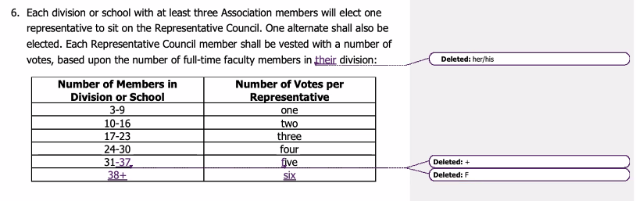
      - Q: Do you have the information for what the numbers were to what they are now with the shift?
      - A: SC AS had a presentation a couple weeks ago that showed the new breakdown with the reorg that has the new total number of faculty in each area.
      - A: Jenny will share the more accurate list of the breakdown of the shift between departments of SC.
      - Q: It is more of a question to see what that breakdown is since it hasn’t been shared before/is not that obvious how those votes have been distributed in the past.
      - A: Currently IVC has 22 total votes and SC has 32
      - Section 8 breaks down that the rep council rep can split/apportion their voters as they see fit to allow for splitting their votes to reflect the different schools/divisions they are representing.
      - There is no changes to the PT representatives.
      - Motion to move forward these changes to allow for the membership for a general vote: Kathy S, seconded: Lewis L
      - Vote: unanimous vote of approve; motion passes.
      - Section 8 Discussion: Change in allowing ANY members to be able to run for any position of Exec no matter if you are full time or part time.
      - 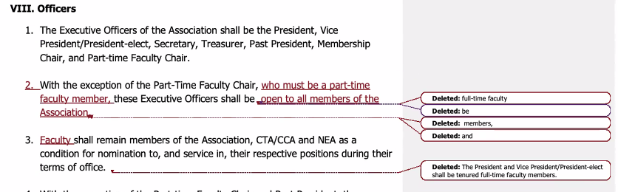
      - Motion to reject this recommendation from the committee with thanks for their work: Kathy S, seconded: Lewis L
      - Friendly amendment – I refer that we do not make the section 8 changes in the bylaws to not forward to the membership.
      - Discussion:
        - C: CTA wants us to open the positions for all to use. But our part-time faculty are at-will employees. If a PT member is elected to president, then they could be fired at any time and disrupt our membership. The way our president role is set up is a 6-year term – 2 as an elect, 2 in the role, and 2 as a past-president. There is a steep learning curve to the role.
        - C: CTA has an issue with the way we set up our executive positions and they WANT us to allow ALL members to be able to run for any positions.
        - C: Rehire rights… if a PT became president and they are no longer teaching, would it then mess up their rehire rights?
        - C: Good point. We don’t have anything in the contract about that. We have language about leave but not really about their rehire rights. There’s no guarantee that the District would do that though. You would potentially be rejecting assignments and lose that priority rehire rights.
        - C: Reassign time is 12 LHE, so the PT would need to take that as stipend. So, they would need to get leave approved to keep the rehire rights. CCA added bylaws that said – you can retain an elected position for a year beyond when you have concluded teaching assignments.
        - C: If part of our concern is that PTs don’t have job security and could be let go at any time, should we then have the representatives be FT tenured faculty? Or, could we also just explain to those PTs interested in the issues that could come with this role? I understand the argument, but it also seems like a pat on the head to everyone else like, “you cannot possibly understand the risks that you are taking.”
        - C: They accept the risk doesn't help what may occur to the Association if a part-time faculty member is tossed. What happens if they lose their job? There is a loss of power when you cannot stand toe-to-toe with others.
        - C: If we want to take that to an extreme, then why do we have PTs on the negotiations or in the rep council?
        - C: The President has to deal with other issues that those roles don’t necessarily have to deal with.
        - C: Having a tenured faculty in the president/vice president allows for a bit of protection for those in those spaces.
        - C: Could any other position on the board be a PT rep? Or are the concerns still there about that? (i.e. like a treasurer or secretary)
        - C: The previous iteration did not allow PT to be in any Exec roles and the FTs could be a PT Chair instead of a PT member. The change will now allow PTs to be in the Exec roles. There are roles and expectations that the Exec roles have that can be better protected when a FT tenured faculty are in the roles.
        - C: Its not a discussion about if PT could do it or are qualified to do it; its more about the fragility of both the roles in the FA and the role PT have in their assignments. Plus the position of the union that they would be placed in if there were errors.
        - Amendment: I recommend to Kathy as a friendly amendment that the language in the original motion changes to say we do not refer the changes to section 8 to the general membership for ratification with the exception of the language to section 8 subsection 2 to include “must be a PT faculty member”
        - Vote: 26 aye, 11 abstention, 2 nay
      - Section 9 - 19: all approved
      - Section Appendix: PAC representatives: updated to add that PT reps will have 2 reps and 1 alternative, PT reps shall be elected by PT membership.
        - Motion to approve: Lewis L, seconded: Amanda J
        - Vote: Unanimous approval; Motion passes
      - Section Appendix C: clarification of roles indicating the FA Vice President role and the chair of the grievance committee.
        - Motion to approve: Lewis L, seconded: Kathy S
        - Friendly amendment: Update the capitalize Grievance Chairs and President in item 2 - accepted.
        - Vote: unanimous approval; motion passes
    - Dates of Election – Roll out on Monday, May 8th to vote on bylaws that were changed/updated. The changes to the bylaws only. The standing rules changes can be made to the document now.
    - The bylaws will be sent out to everyone to vote, and the changes will be included/highlighted there.
- Information
  - Fall Flex Week FA General Meeting – Online – Save the Date: Monday August 14th – 11:30 am
- CCA/CTA/NEA Conferences
  - Spring Conference Report
- Thank you for your service this year! Until the fall……

Meeting adjourned: 5:10pm

