**Minutes**

**Representative Council Meeting**

September 9, 2024

1. Call to Order: 3:06pm
2. Meeting Items
   1. Introduction of Guests
   2. Adoption of Agenda
      1. Motion: Wonderful Nancy A, Seconded: Jenny L
      2. Motion Adopted Unanimously
   3. Approval of Minutes: May 13, 2024
      1. Motion: Allison C, seconded: Wonderful Nancy A
3. Part-Time Chair Executive Council Member
   1. **Action Item** - Voting and Seating of Part-Time Chair Council Membe**r**
   2. Candidates:
      1. Elgitz Baldonado Wilkins
      2. Danelle Huggett
      3. John Terranova
   3. Vote: Danelle Huggett received the most weighted votes from the representatives present. Absent: AMPD (SC), Arts (IVC), 1 PT Rep.
4. Officer and Committee Reports
   1. Secretary’s Report—Marianne Wolfe
      1. Communications Advisory Committee - nothing to report. If you want to contribute to the spring newsletter, please let us know.
   2. Organizing Committee Report— Deanna Scherger
      1. Election volunteer form fall 2024: [https://docs.google.com/forms/d/e/1FAIpQLSfsj1lyfRyhS3eOXhPbvR_djcKmFX2JFZNWz7jbjJq0DUTh5Q/viewform?usp=sf_link](https://nam04.safelinks.protection.outlook.com/?url=https%3A%2F%2Fdocs.google.com%2Fforms%2Fd%2Fe%2F1FAIpQLSfsj1lyfRyhS3eOXhPbvR_djcKmFX2JFZNWz7jbjJq0DUTh5Q%2Fviewform%3Fusp%3Dsf_link&data=05%7C02%7Cmwolfe10%40ivc.edu%7C559dfab7a23842a0a33b08dcceafc904%7C3f01c1a0e05841c798d9b9fc7cf3c3f9%7C0%7C0%7C638612501584893023%7CUnknown%7CTWFpbGZsb3d8eyJWIjoiMC4wLjAwMDAiLCJQIjoiV2luMzIiLCJBTiI6Ik1haWwiLCJXVCI6Mn0%3D%7C0%7C%7C%7C&sdata=Sl4Mxr22KDOD%2BPWKmnOWHVOtIX1joMAVNzaKSldYbdM%3D&reserved=0)
      2. Join us for an Organizing meeting on Zoom, Monday, October 14th from 3-4pm
   3. Part-time Committee Report— Tabled
   4. Treasurer’s Report—Frank Gonzalez
      1. Reviewed 2024-2025 Budget (<https://drive.google.com/file/d/1MrZyceA->)
         1. Note: You need to apply for CCA/CTA grants before we will reimburse you from SOCCCD FA funds.
      2. **Action Item** - Approval of 2024-2025 SOCCCDFA Proposed Budget
      3. Motion to approve: Lewis L, seconded by: Allison C
      4. Q: What are the alternatives to approving the budget?
      5. A: We try to find an agreement and if not able to find one, then we stop operations until we agree.
      6. Vote: Approved unanimously
   5. Negotiations Report—Claire Cesareo
      1. 2024 - 2027 Academic Employee Master Agreement
      2. Tentative Agreement Summary 2024 - 2027 Academic Employee Master Agreement
         1. See attached PowerPoint PDF for summary
         2. Article 14: Assignment, Contract Year, Hours of SErvice, and Professional Duties

Q: Who decided having required trainings?

A: Trainings have always been part of the contract. But some of the required trainings are being asked for by faculty to the Board who then work with FA to create the requirements.

Q: Is there an open agreement about trainings then as long as both faculty and district decide?

A: For the 2 hours of required training, yes. The district determines what that 2 hour training will be.

Q: Example of training content?

A: An example of legally mandated training would be something like the sexual harassment training, while an example of district training would be something like the implicit bias training we had.

* + - * 1. Commencement wording changed - it is now required participation in the official commencement ceremony by all full-time faculty (or ½ day of sick leave).
        2. Office Hours: Designated office hours by non-classroom faculty should be used primarily for student-related work.
        3. PT Faculty can get 1.5 hours per semester of optional PD paid by the district, college. An increase can be approved by VP. Didnt want to limit/have a cap. So we wanted language to demonstrate a minimum.

Q: Are PT and FT separated when it comes to paying for PD?

A: No, FT faculty just have certain hours they have to meet versus PT who can get paid additional funds for their PD.

Q: Why are all the PD paid funding for DEIA?

A: There are educational mandates (Title 5) now that require DEIA training. So, we are trying to support the faculty through paying for those trainings to meet the mandates.

* + - * 1. Faculty response to school/division requests in timely manner (such as stipends approval form). Just making sure people are responding in timely manner.
        2. FT tenure faculty complete 1 peer observation per semester to this article.
        3. DEIA Designated activities or increase teaching and learning effectiveness - we pushed back on them requiring specific percentages of the PD but now have to have at least one thing in your PD connected to DEIA or teaching.
      1. Article 15: Workload
         1. Faculty may be required to teach more than 3 separate preps (but no more than 5) in a given semester. Meaning you can teach 3-5 different classes each semester.

Q: If I am teaching a course both online and in-person does that count towards 2 different preps?

A: Yes, but normally we ask you to work with your deans on this because it is the same prep.

Q: Does this mean I cannot teach more than 5 classes?

A: No, you can do as many as you want if you choose to, but this doesnt allow the dean to force you to do more.

* + - * 1. Overload assignments are voluntary
        2. FT 10 LHE overload - this allows in emergency situations for the 10 LHE overload to be surpassed. But, it has to be voluntary still. Some faculty have been teaching more than 10 LHE, so we wanted it in the language of the contract.
        3. Priority rehire eligibility (PRE) - a course will only count towards PRE if they serve as the instructor for 100% of the term. So if there is a sub that teaches just part of the course, then they are not using it towards PRE. This area also changed language related to COVID related to PRE since we dont use it anymore. And, some provisions were added to protect the PT faculty. If a PT faculty is under investigation for any reason and they have their courses taken away from them, this allow them to stay on PRE and not have that used against them in the case they are allowed to return to campus after investigation.
        4. Extra duty days for counselors - retains 7 extra duty days and just specifies the total hours amount.
        5. Extra duty days were added to Choral (vocal) music director since it was never added in but all the rest of the music directors did have it.
        6. Language added to make extra duty days have to be documented in writing.

Q: For PD, that is an academic senate question?

A: Yes, each college has their own PD funds that goes through Academic Senate and each school.

* + - * 1. Department Chair compensation - restructures the current distribution withing 4 categories. there is a 10.7% growth in the allocations. There is more of an equal distribution based on the different LHE so its more equal for each tier. Department chair stipends go into effect in spring 2025. Stipends/reassign time will go up.
      1. Article 16: PT Faculty
         1. Removed language on automatic interviews (courtesy interviews). There is no line draw anymore and there is a possibility for the hiring committee to interview people after scoring is done. So there is no need for the courtesy interviews.
      2. Article 17: Evaluations
         1. Some timelines changes but the main change was pilot for peer observations in the process where a faculty member being evaluated can elect to have a classroom/worksite observation or a review of student surveys.Now evaluatee can choose one or the other to reduce the classroom visits for the FTs. Student surveys option can only be opted for once every 6 years.
         2. Q: New evaluations, when will those be given out. I was wondering when those will be used/sent for us to use.
         3. A: Many people will already have complete evaluations this fall, so it will go into effect in spring 2025.
         4. Q: Can full time faculty being evaluated this fall choose the student survey option? Or does that happen in only spring?
         5. A: Technically you could use it for the fall once the contract is ratified. But we were trying to launch it for spring since new forms and such arent created yet.
         6. Language that self-evaluation portion of the evaluation (as part of portfolio) include the following:

If course success data disaggregated by race/ethnicity shows lower success rates for any identified group, faculty must provide self-reflection on how to adjust teaching. If percentage falls below 40% for a specific group, they need to include a plan of action to address this disparity along with adding a description of the faculty members DEIA PD, learning, teaching, etc

* + - * 1. Evaluation instrument will be revised to make cleaner and simplified.
      1. Article 19: Transfers
         1. Added language that if there is a conflict of interest at the college that you want to transfer to, seniority is not considered.
      2. Article 20: Travel - minor language changes that dont make impacts.
      3. Article 21: Health and Safety - if FA requests a meeting of the Health and Safety committee, it needs to convene within 30 days.
      4. Article 22: Layoff Procedures and FSAs
         1. Changed Faculty Service Aeeas (FSAs) from a single FSA to align with all the disciplines/areas list and its specified minimum quals. We are all hired for a particular discipline (or FSA). By having multiple FSAs, you will have a list of all the disciplines you can teach in. This only applies to layoffs. So if you are getting laid off, then you can move to another FSA that you could teach in instead. We dont anticipate layoffs any time soon, but this is just in case.
         2. There will be a process developed to be able to update their FSAs. It also adds procedure for layoffs including 5 days of paid leave used in seeking other employment, continued benefits for 90 days and additional items like severance pay.
      5. Article 26: Bonded Sabbatical and Professional Development Leave
         1. Restructured Sabbatical committee to include 1 rep for every 32 FT faculty in school.
         2. Also adds language that says previously years towards sabbatical earned are kept. EX: If you are a FT faculty who becomes administrator who then retreats, it counts the years prior to administration role to count towards sabbatical.
         3. Adds language that sabbatical committee can use president’s recommendation as a consideration when making the decision.
         4. If you are on sabbatical, you can still access PD funds to attend conferences and such
      6. Article 27: Benefits
         1. No changes to FT benefits
         2. PT health insurance allowance - We tried to connect with the state legislation but it ended up making some PT lose money. We made changes to this to include:

Doubled amount of money available for PTs ($384,000 to $768,000 per semester). This a pot of funds across the schools. In the last few semesters, faculty had to take a reduction from the previous amount. Now we hopefully will not see reductions and people can receive the whole amount.

Reduced 12 LHE in prior months to 9 LHE along with 4 semesters of employment instead of 6 semester, so hopefully more can take advantage of this benefit.

If Long term disability insurance becomes unavailable or premiums increase by over 50%, FA will negotiate any change in benefit.

Q: Do you advocate for vision, dental, etc for PTs?

A: We try to but have not been able to get them to grant that to us.

* + - * 1. Added language about purchasing semester long permit instead of annual parking permit.
      1. Article 28: Workload Banking
         1. Adds ability to take partial banked load leaves once every 6 semesters, full leave is once every 8 semesters. They did not want to have people bank and then take a reduction of courses multiple semesters in a row. If there are no issues, we can reopen this in the next contract.
      2. Article 29: Leaves
         1. Adds 1 week paid parental leave, no deduction from sick leave
         2. Bereavement - they can ask for documentation but they might not
      3. Article: Wages
         1. Thsee are the amounts we negotiated but is based on COLA but not contingent on COLA. It is not COLA + %. It is just the set amount of the overall raises.
         2. 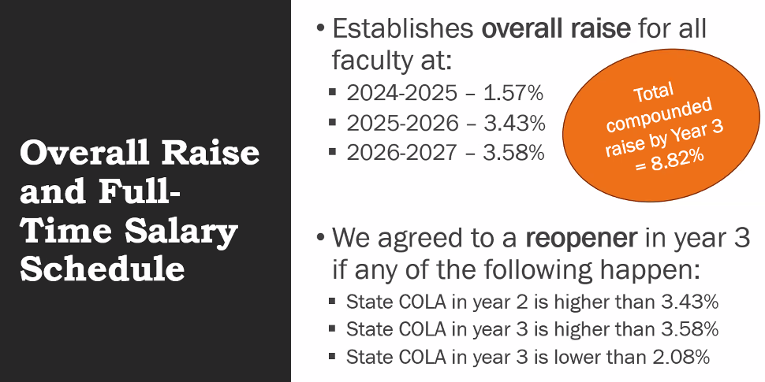
         3. 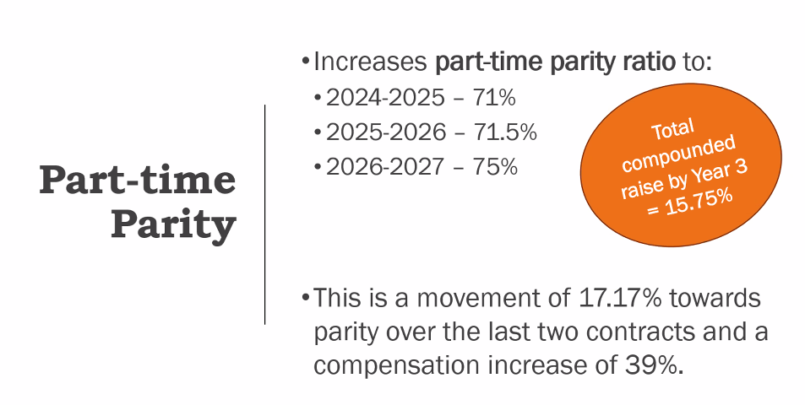

We know we are not at parity but we are pushing and advocating as much as possible. We are creating momentum to work towards increased parity.

* + - * 1. 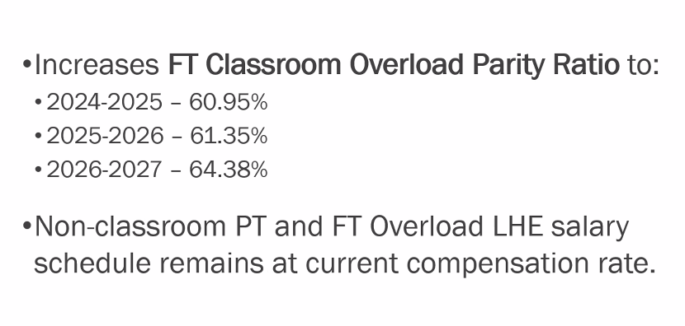

Ratios are increased in all areas. Non-classroom PT and FT overload LHE salary will not increase in parity. LHE rate for non-classroom and FT overload will remain exactly the same and will look like it looks in the last contract.

* + - * 1. 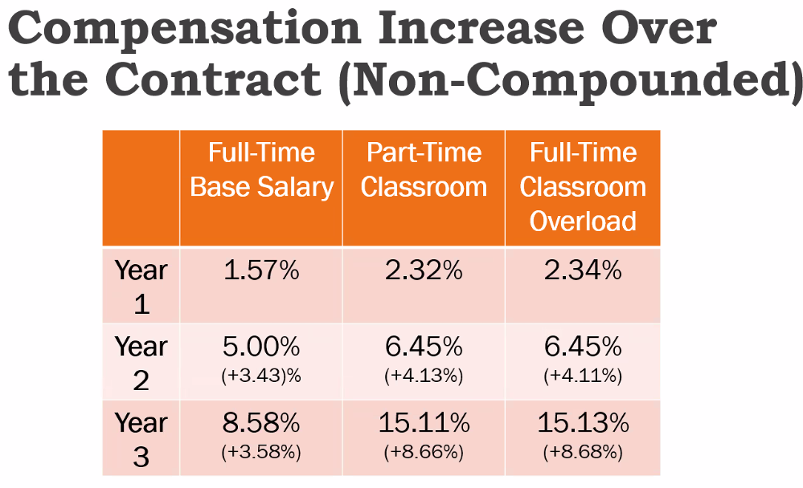
        2. Q: Are we going to try to look into PT being paid 30% more for teaching online?
        3. A: Yes we can look into that. Are we sure it is not large lecture that they are being paid more?
        4. A: No, I can ask them again and find out which specific schools. They didnt say which subjects but that it was teaching online.
        5. A: It was my understanding that teaching online was the same as teaching in the classroom.
        6. A: We have always maintained that a class is a class no matter what modality.
        7. Q: Thank you to Claire and everyone involved to make it happen. I can only imagine making this happen. It is fantastic news, thank you to everyone involved. I am pretty sure our PTs will be happy to hear this news. Both FT and PTs will be happy.
        8. A: Thank you to all the faculty who came to the meetings and showing up to the Board. They did listen.
        9. 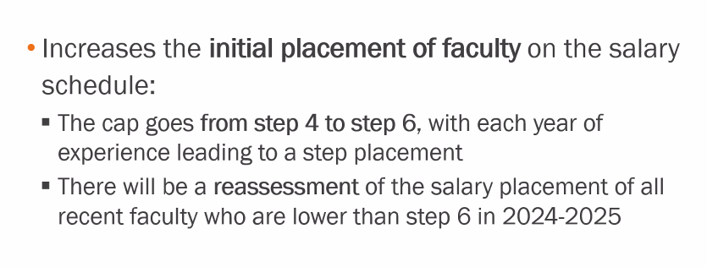
      1. Article Retired Faculty Benefits
         1. Updates language on legal changes regarding reduced workload program.
         2. If a faculty member is presented with a formal charge by the district, they cannot retire or resign and keep lifelong medical benefits until evidentiary hearing is concluded. They will be placed on paid admin leave, and then with the final decision of the hearing
      2. Q: Commend the negotiation teams from FA. When comparing to the other negotiations teams across the state
    1. **Action Item** - Approval to move tentative agreement forward for a ratification vote by membership
       1. Motion to approve ratification of tentative agreement: Allison C, seconded: Wonderful Nancy
       2. Vote: Passes ratification; one abstention
    2. General Membership Meeting on the Contract - Monday, September 23, 2024 from 3:00pm - 4:30pm (Zoom Link: [https://saddleback-edu.zoom.us/j/87341895163](https://nam04.safelinks.protection.outlook.com/?url=https%3A%2F%2Fsaddleback-edu.zoom.us%2Fj%2F87341895163&data=05%7C02%7Crmelendez%40ivc.edu%7C4356327baa6b41f7f80908dcd07d65b8%7C3f01c1a0e05841c798d9b9fc7cf3c3f9%7C0%7C0%7C638614484350411311%7CUnknown%7CTWFpbGZsb3d8eyJWIjoiMC4wLjAwMDAiLCJQIjoiV2luMzIiLCJBTiI6Ik1haWwiLCJXVCI6Mn0%3D%7C0%7C%7C%7C&sdata=7IkZVUJ7FFkdYjWff2PMVDbCKjJriexIKOsqwvP2ZIk%3D&reserved=0))
       1. Ratification Vote for all Faculty Association members to take place between Tuesday, September 24th - Monday, September 30th.

1. Motion to extend the meeting 15 more minutes
   1. Motion: Lewis L, seconded: Jenny L
   2. Vote: Approved unanimously
2. PAC Report – Robert Melendez
   * 1. PAC – Approved for Endorsements for Trustee Elections
        1. [Area 1](https://www.socccd.edu/sites/default/files/2022-07/Area%201%20detail%20map.pdf) – Carolyn Inmon – Incumbent (approved $5K)
        2. [Area 6](https://www.socccd.edu/sites/default/files/2022-07/Area%206%20detail%20map.pdf) - Ryan Dack – Incumbent (approved $5K)
        3. [Area 3](https://www.socccd.edu/sites/default/files/2022-07/Area%203%20detail%20map.pdf) – Rocky (pledged $30K for marketing)
     2. **Action Item** - PAC – Recommendation for Endorsement for Trustee Elections
        1. [Area 7](https://www.socccd.edu/sites/default/files/2022-07/Area%207%20detail%20map_2.pdf) - Tim Jemal (pledged $ for filing fee)
     3. Motion to approve endorse of Tim Jemal: Lewis L, seconded by; Wonderful Nancy
     4. Discussion
        1. C: I know the opponent on a personal level who is openly against unions. He has worked at for-profit colleges and they target veterans. They are unqualified to be on the Board and can do more harm for us. They identify as education executive and has a poor candidate statement but he has military background and education executive component that could sway voters.
        2. C: Now with the area elections, it might be easier to unseat an incumbent.
        3. C: Opponent: Carl David - <https://ocvote.gov/fileadmin/user_upload/elections/GEN2024/cs/3064-2.pdf>
        4. Vote: Approved unanimously
   1. CCA/CTA Regional Report – Sam Abbas
      1. CCA State Report: Not much in summer besides the CTA president's conference, CTA summer institute in LA, and on the 20th I have a board meeting in Sacramento. I am serving on a DEIA Panel at the CCA Fall conference (October 25-27) in San Francisco. We need delegates for that conference.
3. Information (*tabled*)
   1. SOCCCD Data Leak
   2. Prescription Drug Changes for Blue Shield PPO
   3. CCA/CTA/NEA Conference

Fall 2024 Conference – October 25-27, 2024 – The Westin, San Francisco Airport

1. Next Meeting: Monday, October 7, 2024
2. Announcements/ Misc.
3. Adjourned 5:12pm

**Meeting Attendance**

| President | Robert Melendez | X | President Elect | Deanna Scherger | X |
| --- | --- | --- | --- | --- | --- |
| Past-President | Lewis Long | X | Chief Negotiator | Claire Cesareo | X |
| Treasurer | Frank Gonzalez | X | Membership Chair | Jenny Langrell | X |
| Secretary | Marianne Wolfe | X | Part-Time Faculty Chair | VACANT |  |
| Grievance Chair (IVC) | Kathy Schmeidler |  | Grievance Chair (IVC) | BIll Etter | X |
| Grievance Chair (SC) | BIll McGuire | X | Grievance Chair (SC) | Mark Blethen | X |

| Arts (2) | VACANT |  |  |  |  |
| --- | --- | --- | --- | --- | --- |
| Business Science (2) | Rick Boone | X |  |  |  |
| Guidance & Counseling (3) | Javier Valdez | X | Guidance & Counseling (Alt) | Parisa Soltani |  |
| Humanities (3) | Lewis Long | X | Humanities (Alt) | Deanna Scherger | X |
| IDEA (1) | Massimo Mitolo | X |  |  |  |
| Kinesiology, Health, & Athletics (1?) | Jovan Stojanovski | X |  |  |  |
| Languages & Learning Resources (3) | Keith Gamache | X |  |  |  |
| Life Science & Technology (1) | Pierre Nguyen | X | Life Science & Technology (Alt) | Kathy Schmeidler |  |
| Math, Computer Science, & Engineering (2) | Carlo Chan | X |  |  |  |
| Physical Sciences & Technology (2) | Amy Stinson | X |  |  |  |
| Social and Behavioral Sciences (1) | Adam Ghuloum | X |  |  |  |

| Arts, Media, Performance, & Design (5) | BIll McGuire |  |  |  |  |
| --- | --- | --- | --- | --- | --- |
| Business & Industry (2) | Emily Quinlan | X | Business & Industry (Alt) | Kathleen Lunetto | X |
| Counseling & Special Programs (4) | Paris Peck | X | Counseling & Special Programs (Alt) | Mike Long |  |
| Extended Learning (1) | Jill Ibbotson | X |  |  |  |
| Health & Wellness (3) | Loretta Niccola | X | Health & Wellness (Alt) | Samantha Barrett | X |
| Humanities & Social Sciences (6) | Allison Camelot | X | Humanities & Social Sciences (Alt) | Pete Murray |  |
| Kinesiology (2) | Matt Sherman | X | Kinesiology (Alt) | Jennifer Rohles | X |
| Instructional Support and Teaching Innovations (1) | Jenny Langrell | X | Instructional Support and Teaching Innovations (Alt) | Lydia Tamara |  |
| STEM (6) | Kia Shafe | X | STEM (Alt) | Sam Abbas | X |

| Part Time Representative (1) | Nancy Allah | X | Part Time Representative (1) | Noushin Seddighzadeh |  |
| --- | --- | --- | --- | --- | --- |
| Part Time Representative (1) | Danelle Huggett | X | Part Time Representative (1) | John Terranova | X |

Guests:

Sam Abbas

Kurt Meyer

Grace Chau

Chris Condron

Jane Medling

Daniel Vernazza

Maureen Smith