**Minutes**

**Representative Council Meeting**

November 4, 2024

1. Call to Order (3:05PM)
2. Meeting Items
   1. Introduction of Guests
      1. Grace Chau
   2. Adoption of Agenda
      1. Motion to adopt agenda: Kathy S, seconded by Lewis L
      2. Approved; no abstensions no nays
   3. Approval of Minutes: October 7, 2024
      1. Motion to adopt the minutes: Kathy S; seconded by Nancy A
      2. Approved; no abstensions no nays
3. **Action Item** - Seating of Representative Council Members
   * 1. SC Humanities and Social Sciences Alternate: Caroline Gee
     2. Motion to seat: Kathy S; seconded by Nancy A
     3. Approved
4. Officer and Committee Reports
   1. Secretary’s Report—Marianne Wolfe
      1. Communications Advisory Committee
   2. Organizing Committee Report— Deanna Scherger
      1. We met and are trying to get more consistent involvement
   3. Part-time Committee Report— Danelle Huggett
      1. November 22nd, 10am-12pm - How to apply for FT position workshop
      2. December 13th, 10am-12pm - How to apply for Unemployment workshop
      3. Spring - How to apply for PT insurance
         1. Q: Can you add an additional workshop to December that people can apply during the winter break for the benefits? People dont know when they can apply.
         2. A: We just got all the information for “How to Apply for a FT position” soon and we will send out the information about the other workshops before the end of the fall semester.
         3. Q: Are you going to send it out to the new hires before the end of fall? How are you going to send out the information?
         4. A: We will email all the PT faculty before the end of fall.
         5. C: However, new people aren't eligible for the part-time health benefit right away. One must have worked for several semesters to qualify for the health benefit. The District email to qualifying part-time faculty members for the health benefit goes out in January.
         6. C: We try to update everyone on all the information regarding benefits and signing up for things. If you think we are missing gaps or places, please let us know.
   4. Treasurer’s Report—Frank Gonzalez
   5. Negotiations Report—Claire Cesareo
      1. Contract was approved. In the last paycheck you should have gotten your new salary schedule payment amount. The retropay will come in your November paycheck.
      2. Some things for effect in the spring: new chair stipends and evaluation process. Some minor changes to the evaluation forms and it cuts out some redundancies. Right now we are working on a template that will be posted into the website that has all the evaluation forms. For the most part, it is pretty much the same.
         1. Chair stipends: When can we know when those amounts are more specific?
         2. A: It should go into effect in spring. They should have the numbers and know when it will go out in the spring. It is all ran through the Office of Instruction. Hopefully it should go out ASAP. Most people are going up, but a couple will be reducing.
         3. Robert will check in with Rick and Tram to find the new numbers and where they are in the process. Some areas have already gotten the information and some have not heard anything yet.
         4. Q: For smaller departments, I’m worried the funds will decrease. The work we do is still the same even if we are smaller schools/departments. Do we know roughly what kind of raise to expect in percentage terms?
            1. A: For full-time faculty for normal load, 1.57% for this academic year, 3.43% next year, and 3.58% for the third year. 8368% cumulative raise, or 8.82% compounded raise. There was not a percentage increase for chair stipends, but a shift in the table used to calculate stipends, so there really isn't an easy answer. It varies depending on the department.
            2. Overall, there was an increase in the total amount paid out for stipends, but each department will see a different variation.
         5. About 80% have gone up. The smaller size of the school doesnt necessarily equate to going down if you are a smaller department. It just depends on the category and the tier of the category now. Department chairs of CE programs are also eligible for the supplemental duties funds.
         6. C: The supplemental pay is not very easy to get. There seems to be a lot of paperwork and reporting out directly to the VPI with extra hoops before getting approved for the supplemental pay.
         7. C: The supplemental pay process might need to be looked at as well though the VPI tends to be more open to the funding.
         8. C: I am also a CE faculty though not the chair. I keep having to do extra (drive my own car, stay after hours, work through dinner times, high school meetings and conferences, etc) that has no pay.
         9. A: FA doesn’t negotiate individual stipends, that would need to be determined between the faculty member and the dean. That’s outside of our purview.
      3. We are going through the contract, line by line, to find typos and any redundancies and other things that may be missing. Once that proofing is done, we will get the signed versions online. It should be done in the next 2-3 weeks.
         1. Q: Is it possible to negotiate that anyone who is employed here to have some compensation for health care instead of requiring them to have a certain number of terms before getting beenfits?
         2. A: Negotiations are over this time around, but we will continue to work on making things better each contract. We doubled the amount of money PTs can get for the health benefits, so we are doing what we can to try to move towards everyone getting benefits as possible. We reduced the 12 LHE to 9 LHE as well.
         3. C: I’m happy that it was reduced to the 9
         4. C: We thank everyone in the negotiations team for all their work. We know other districts have made big strides too, so we know people
         5. Q: Does FA have any connection to faculty stipends for professional development stipends? I went to a conference recently with other faculty from other Districts. And it seems like SOCCCDs stipends have not been increasing with inflation and such.
         6. A: No, that is an Academic Senate’s vote. They do review the amounts often.
         7. Q: PTs also don’t have very much allotted to them.
         8. A: However, again, PD stipends and funds are not in any way in the province of the FA. It's a Senate issue. Also, it is not really a “stipend” since there are other connotations and requirements for stipends that PD opportunities. Also, IVC and SC Academic Senates run separately from one another. Each school has different processes, amounts they allocate, different priorities, etc.
         9. Q: Will the Senates consider combining?
         10. A: No, it probably will not happen. You can also bring this up to Senate since this is a 10+1 issue.Professional development is a "10+1" issue, so by law it belongs to the Senate, and the FA has no standing. But we're all members of both bodies.
   6. Membership Report—Jenny Langrell
      1. Membership Advisory Committee
         1. Minor changes but nothing too drastic (see report)
         2. Q: How can we get the PT faculty to join and know what the FA does for them?
         3. A: We have turnover every month but hopefully the Rep Council representatives share out the information with their areas as well as our larger emails can reach them. If we can have more events and direct contact with the PTs, it can help encourage their involvement in the union. We hosted one last spring that was very successful.
         4. Q: Can we send emails to everyone who are not members?
         5. A: As a representative from my school, I have been sending out emails to everyone in my school. Jenny sends out the lists of those who are members and who are not.
         6. A: Jenny will send out an updated list to all the reps and chairs for each school who you can help reach out to the other non-members.
         7. Q: Do people who are members and who are not still get the perks and benefits that we negotiate for?
         8. A: Yes, there’s a lot of different reasons people don’t join. There’s benefits that apply to everyone (like the contracts). Non-members don’t get access to the CTA lawyers and other perks that union members do get. Personal approach is helpful to get people to understand the importance of being a member. FA participates in the new hires orientation and hosts a lunch for them every year.
         9. Q: I tried to recruit someone who told me that the FA is working with the system to not get parity. As long as the FA doesn’t change, then they did not want to join.
         10. A: That is false news/alternate facts. The person does not have the right facts. Maybe we can put together some bullet points on why and how the PTs are valued and supported by our District.
         11. 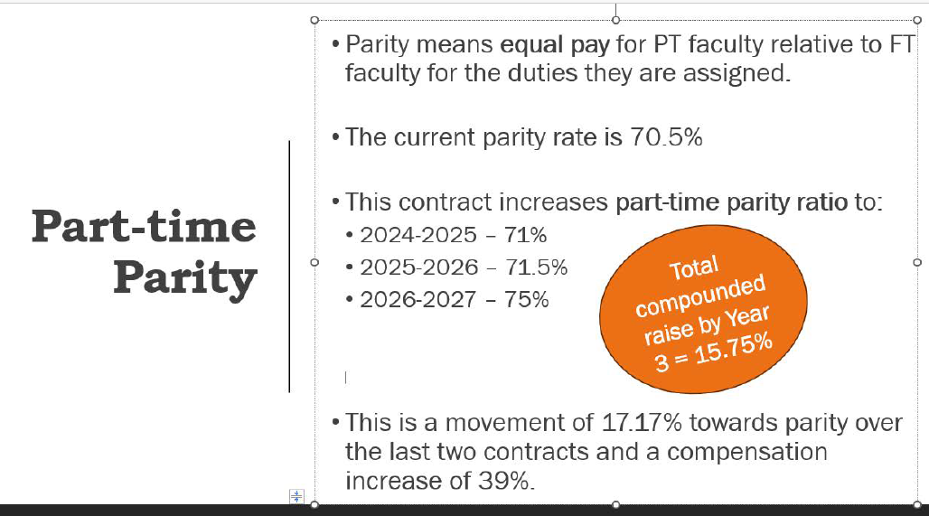
         12. Q: Can we share where the money from our membership goes?
         13. A: Jenny will share it in an email for everyone.
             1. Some benefits listed from CTA website: <https://www.ctamemberbenefits.org/thestandard?gad_source=1&gclid=Cj0KCQiA_qG5BhDTARIsAA0UHSLOmhsrSfg_6LvdIXy_1GLIN5ugpY4AGDmUNb2l7RPxUXv9r-maidEaAgLiEALw_wcB>
         14. A: Some members used legal support and benefits from the CTA union membership recently in our district. The power of the union is good for negotiations but it also is important to protect yourself as well.
         15. Q: Why take on grievances for those who are not members?
         16. A: The purpose of grievances helps everyone in the membership since it deals with the contract and how it is being interpreted. We help at the local level and if it escalates, then it could need the CTA support. When faculty are dealing with problems, we don’t always have time to ask if they are members or not. In addition to that, a problem for any faculty (member or not) could be a problem most people are facing. Who are we and what are we if we don’t help those in need and only help those who pay money. We should ask ourselves that individually and as an association on what we want to stand for. We have an obligation to represent all of the members of the unit, even if they are not paying dues to the Association. That is part of our duty as the legal designated representative.
         17. Q: When you join, can you selectively decide what you pay? Like I only want to pay for the SOCCCD dues not NEA or CTA?
         18. A: It’s all or nothing. The CTA is a parent group. We got PAC funding from CTA to help support our candidates. They pay for us to attend conferences. We rely on the resources through CCA/CTA. We have reached out to CTA and liaisons for multiple of issues that our district has faced. There’s also great discounts for travel and car rentals (better than Costco).
         19. Q: Does anyone have car insurance through CTA? It’s only available for firefighters, nurses, and teachers.
         20. A: A couple people do and enjoy the insurance. Submitting a claim is also not bad.
         21. Q: Where do we submit for PT disability insurance?
         22. A: SOCCCD does not have PT disability insurance. But CTA might have something that you can get but we have not looked into it as a district because district did not want to pay it.
   7. Grievance Committee
      1. IVC Spring 2025: Kathy (IVC) will be going on sabbatical for spring. We have a faculty member who has expressed interest in stepping in for her - for spring as well as a long term role.
   8. PAC Report – Robert Melendez
      1. Election Campaign Update/Recap on what has been done so far
         1. We are supporting candidates for Area 1, 2, 3, and 6. Most are incumbents for the seats.
            1. Area 3: Rocky Cifone got most of the efforts due to the uncontested seats. We sent out 3 mail pieces, 2 different sets of text messaging (60K numbers), social media ads (still ongoing through all Meta sites), lawn signs, canvassing, get to know the candidate event at a faculty member’s house, walk pieces that allowed people to meet the candidate.
   9. CCA/CTA Regional Report – Sam Abbas (tabled)
5. Information
   1. CCA/CTA/NEA Conference
      1. Fall 2024 Conference – October 25-27, 2024 – The Westin, San Francisco Airport
         1. Report from Delegates (Sam, Nancy, and Noushin)
            1. Nancy attended the leadership conference. In one of the sessions, they advised people to have disability coverage. There’s a meeting every conference. There’s a state council that meets and we are allowed to go to that as well.
            2. There’s a lot of leadership roles in the variety or spaces and areas that these trainings can be good for. It’s a great opportunity to learn and participate in these trainings. If you have questions about the leadership academies that CCA offers, you can reach out to Nancy.
            3. They are often encouraging and looking for faculty to get involved with legislation and other committees outside of districts and on a statewide level.
            4. If you are interested, please reach out to CCA President: Eric Kaljumägi [president@cca4us.org](mailto:president@cca4us.org)
      2. Upcoming CCA Conference - let us know if you plan to attend as a delegate!
         1. Winter 2025: February 7-9, 2025
         2. Spring 2025: April 25-27, 2025
   2. Extra Duty Days
      1. Payment for part-timers getting paid for extra duty days. There was some questions about how the extra duty days would be paid out. It should be an even paycheck spread out throughout the semester instead of timesheets/timecards per day worked.
   3. Window coverings issue at Saddleback College
      1. District sent an email saying faculty could not have coverings on their windows and not meet with students with a closed door. FA pushed back and talked about the safety issues with not having coverings on windows. District also suggested that we should not meet with students with the door closed.
   4. Part-Time Faculty LHE Max Load
      1. It is permissible for a part-time faculty member to teach over 10 LHE in any one semester of an academic year as long as they remain under 20 for the entire academic year.
         1. SOCCCD can assign up to 20 LHE per academic year and remain compliant with the 67% rule because the District defines its full-time faculty load limits in terms of annual load.
      2. Anything over 11.25 prompts a change in pay and you need approval from the college.
      3. Part-time Faculty cannot teach over 12 in a semester.
      4. The district will still be tracking this somehow and will most likely advise people to not make this a common thing due to cost.
6. Announcements/ Misc.
   1. If you have any agenda items added to the agenda, please send us the information and we can add it to the agenda.
7. Next Meeting: Monday, December 2, 2024

Adjourned 4:40pm

**Meeting Attendance**

| President | Robert Melendez | x | President Elect | Deanna Scherger | x |
| --- | --- | --- | --- | --- | --- |
| Past-President | Lewis Long | x | Chief Negotiator | Claire Cesareo | x |
| Treasurer | Frank Gonzalez |  | Membership Chair | Jenny Langrell | x |
| Secretary | Marianne Wolfe | x | Part-Time Faculty Chair | Danelle Huggett | x |
| Grievance Chair (IVC) | Kathy Schmeidler | x | Grievance Chair (IVC) | BIll Etter | x |
| Grievance Chair (SC) | BIll McGuire | x | Grievance Chair (SC) | Mark Blethen |  |

| Arts (2) | Gokce Kasikci | x |  |  |  |
| --- | --- | --- | --- | --- | --- |
| Business Science (2) | Rick Boone | x |  |  |  |
| Guidance & Counseling (3) | Javier Valdez | x | Guidance & Counseling (Alt) | Parisa Soltani |  |
| Humanities (3) | Lisa Alvarez | x | Humanities (Alt) | Daniel Vernazza | x |
| IDEA (1) | Massimo Mitolo | x |  |  |  |
| Kinesiology, Health, & Athletics (1) | Jovan Stojanovski | x |  |  |  |
| Languages & Learning Resources (3) | Keith Gamache | x |  |  |  |
| Life Science & Technology (1) | Pierre Nguyen | x | Life Science & Technology (Alt) | Kathy Schmeidler | x |
| Math, Computer Science, & Engineering (2) | Carlo Chan | x |  |  |  |
| Physical Sciences & Technology (2) | Amy Stinson | x |  |  |  |
| Social and Behavioral Sciences (1) | Adam Ghuloum | x |  |  |  |

| Arts, Media, Performance, & Design (5) | BIll McGuire | x |  |  |  |
| --- | --- | --- | --- | --- | --- |
| Business & Industry (2) | Emily Quinlan | x | Business & Industry (Alt) | Kathleen Lunetto |  |
| Counseling & Special Programs (4) | Paris Peck | x | Counseling & Special Programs (Alt) | Mike Long |  |
| Extended Learning (1) | Jill Ibbotson | x |  |  |  |
| Health & Wellness (3) | Loretta Niccola | x | Health & Wellness (Alt) | Samantha Barrett | x |
| Humanities & Social Sciences (6) | Allison Camelot | x | Humanities & Social Sciences (Alt) |  |  |
| Kinesiology (2) | Matt Sherman |  | Kinesiology (Alt) | Jennifer Rohles |  |
| Instructional Support and Teaching Innovations (1) | Jenny Langrell | x | Instructional Support and Teaching Innovations (Alt) | Lydia Tamara |  |
| STEM (6) | Kia Shafe | x | STEM (Alt) | Sam Abbas |  |

| Part Time Representative (1) | Nancy Allah | x | Part Time Representative (1) | Noushin Seddighzadeh |  |
| --- | --- | --- | --- | --- | --- |
| Part Time Representative (1) | Jean Proppe | x | Part Time Representative (1) | John Terranova | x |