**Minutes**

**Representative Council Meeting**

April 7, 2025

1. Call to Order (3:06pm)
2. Meeting Items
   1. Introduction of Guests
      1. Jane M, Chris C
   2. Adoption of Agenda
   3. Approval of Minutes: [March 3, 2025](https://docs.google.com/document/d/1cSsOMmCq5PFpmpieZWMJCIvzCZFM0suz/edit?usp=drive_link&ouid=111103824869811273500&rtpof=true&sd=true)
      1. Motion to approve: Allison C, seconded by Jenny L
      2. Motion approved
3. Officer and Committee Reports
   1. Secretary’s Report—Marianne Wolfe
      1. Communications Advisory Committee: no updates. We normally try to get a newsletter copy out by the end of the semester.
   2. Organizing Committee Report— Deanna Scherger
      1. Please continue to send us topics you would like to see us host workshops, events, etc on. We look forward to planning more events in the fall.
   3. Part-time Committee Report— Danelle Huggett
      1. Upcoming workshops for spring: How to Interview for FT positions - Friday, April 11, 2025 from 1pm-3pm. Very robust panelist list, please tell your PT faculty about this workshop! We do not normally record the workshops to protect the members who attend and ask questions. But we will send out the notes/materials after the workshop to the PT members.
      2. Part-Time Appreciation event on Friday, May 16th from 1pm-3pm at Saddleback in SSC
      3. One more workshop is being added before the end of the spring semester. Stay tuned for that!
   4. Treasurer’s Report—Frank Gonzalez
      1. Everything in budget spending is still adhering to normal expenses/spending at this time.
         1. Budget: [2024-25 SOCCCDFA Apr 2025.pdf](https://drive.google.com/file/d/1miB-5K3ZfIF1gDvtZVDK4aGUCJrRLa5b/view?usp=sharing)
         2. Please consider the voluntary PAC paycheck contribution: <http://www.socccdfa.net/ESW/Files/PAC_Payroll_deduction_form%5B1%5Dfillablepdf-1.pdf>
      2. Faculty Association Dues Discussion Follow Up
         1. Recap: A few years ago we increased FT membership fees from $20/month to $25/month. We chose not to increase the PT membership feeds at that time. Reasons FA budget/funding has been decreasing: change in fair pay laws due to Janis decision, full-time membership is about 89.24% participation and part-time membership is only at 24% and decreasing steadily, increase of costs of things, etc
         2. Q: Will the increase be communicated by the FA or are we supposed to disseminate the news to our schools?
            1. A: The ask was for both the school reps and PT reps to talk with all faculty about the request. Today is still for discussion with a vote in May.
         3. Q: What is the Janis decision?
            1. A: <https://publications.csba.org/issue/fall-2018/janus-v-afscme-and-new-california-legislation/>
            2. Janis decision (from an out of state lawsuit) stopped the ability for unions to collect the “fair share” from all “unit members,” whether they were a “union member” or not. Now, a faculty has to sign a member form to be a member/have dues deducted. Before Janis, every faculty had dues deducted whether they were a member or not. Helped pay for the work of the union that everyone benefits from, like contract negotiations, dispute assistance, grievance, etc.
         4. Q: With PT roles not being secure, what happens to those who do get assignment changes? Are they dropped?
            1. A: You are not dropped from the membership. Normally it is about 18 months before CTA drops you.
         5. Q: Are we thinking of also increasing the FT membership as well or just the PT? I think it was brought up previously as an option.
            1. A: It was brought to the floor at the last meeting but we haven't had much discussion about that as an option or seem to be what the rest of the group seems to be considering.
         6. Q: Are there any reports on the loss/gains for the memberships if we increase dues? Can we choose to only support the local dues instead of the state bodies as well?
            1. A: It doesn't seem like there would be a loss in membership due to the $4/months. The FT would still stay at the current amounts ($25/month) and the PT would go from $6/month to $10/month. Just a reminder, ever since the local dues had been $20/month until we increased it a few years ago and the PTs have been at $6/month as well. Most of the funds collected are used for personnel (release time and stipend time to allow for union duties). Others have inquired about this before. They have been interested in supporting local only but not CTA/CCA. There is no way to do this though. We are not allowed to take individual contributions towards the membership - only to the PAC funds.
         7. Q: We may think the $4 increase may seem small and irrelevant but sometimes that makes all the impact on whether or not they are going to join/stay members. Can we have this discussion with PT faculty before we make this decision?
            1. A: PT Chair talked with PT Rep Council Representative. They didn’t feel like the $4/month increase was too unreasonable of an ask.
            2. C: The question is more of letting them know about the increase and having their input so they are not as shocked or feel as though they are not being included in the conversations and decisions being made for their membership.
            3. C: We can still send out a survey but it feels like the discussion is leaning towards increasing the membership fees. So, if they vote that they do not want the increase, then where would we get the money from or what would be the next steps or the alternative since we need the increase?
            4. C: If the vote from the PT comes out that they do not want the increase, then we could have the discussion about where else can we increase funds.
            5. AC We need more money so we are not sure where else to find the funding. There is a sticky feeling with hosting an appreciation event and then also telling them there is an increase in their funds.
            6. C: Even if we lose members from this increase, we would still be making money. The only way for the revenue to go down would be if we lost 40% of our PT membership from the increase.
            7. C: We will also try to send out information for transparency purposes as well as rely on our rep council reps to share with their constituents since the PTs have mentioned they do not always get the email notifications. Along with letting them know about the increase, maybe we can share the benefits of the union - benefits, power, rights - that are part of the strength/use of the union. All the work we do locally comes from the union dues. I think we all need to do a good job on selling our colleagues on why this is a good thing to increase dues.
         8. C: I tried to recruit someone last week and shared all the benefits of joining the union. I am thinking of having a PT appreciation dinner and offer some refreshments to them and use money for the membership needs instead. Can we slowly increase the membership dues (like $1 per year) instead of hosting events to show appreciation?
         9. Q: Do you have some talking points that we can share with the members/potential members? I think that would be helpful to have and highlight for the membership.
         10. C: I don't find it unfair to increase part-time dues. In percentage terms, the dues are still not going up by as much as part-time salaries have gone up, since the last time part-time dues were increased.
         11. C: From a business perspective, the $1mil liability insurance from CTA is a huge resource for PT faculty. In a year, the union dues would cover only 1-hour or less of a lawyer (not to mention a retainer). On the liability benefit, it’s huge. I can give you several examples of faculty involved in an “issue,” though not at this district. Not to scare people, but take an upset student who doesn’t like their grade. It’s pretty easy to sue people in California and claim whatever they want. Whether the complaint is valid or a lie, a faculty has to defend themselves. The district doesn’t protect you, it has to investigate you. Hopefully that gives some insight into the process and possible costs out of pocket to protect yourself with no union help outside the local.
         12. C: There is a need to show the value of the PT membership. What works has been PT appreciation events where we show our support and appreciation of those members. If there are pamphlets or other materials that we can use to highlight what the union has done for the PTs. There’s also money that we can apply for to increase membership or get grant funding from CCA/CTA to increase membership.
         13. Q: As reps, in addition to the talking points on the benefits of membership, it would be nice to have an explanation of why we are only increasing PT membership and not FT as well. Can we have some talking points on to why it is not unfair?
             1. A: Yes, we can try to include that as well as the other points that have been brought up today.
         14. Q: Nancy serves on a committee that has a grant for PT funding. She mentioned they have to list everything on there that we plan to spend money on and could possibly get money that way for these events/items.
      3. As a reminder, the Rep Council will make the ultimate vote (in the May Rep Council meeting) on increasing dues or not. If we choose to vote not to increase dues for the PTs, then we will need to discuss where to make budget cuts/changes due to the decreasing funding. The ask is to request for you to have those conversations with your areas about the increase and be ready to vote at the next meeting.
   5. Negotiations Report—Claire Cesareo
      1. No updates. All issues are resolved in the last contract with the exception for the faculty areas. The Banner issues have stalled those discussions.
      2. Q: In the last contract, faculty are able to be paid for DEIA development - how can people go through that or is there a form they can submit?
         1. They need to work with their dean/VP to address that. What has been the process was the campus hosted an event and offered it to the faculty to attend and be compensated for that PD training. Most people, over the past few years, have been doing more voluntary DEIA PD work. There is no official process for getting compensated for that PD training. It could be something that we bring up with the PD committees to make sure they offer enough opportunities for funded PD.
         2. C: IVC has a part-time paid PD options for many events, but it seems like that is more specific to their school and how they process it.
         3. C: Robert can bring this up to the IVC and SC Flex Coordinators to see what each school is doing and making sure there is enough money/activities to fulfill the PD requests/wants.
         4. Q: If there is a way to make if official, it could increase the participation in the PD events.
            1. A: Every year we push for a certain amount of PD for the faculty. We have been looking for full parity - which would include the service to the college/PD for the college. We have not been able to win but we advocate for the 100% parity (including all the duties they have as well).
         5. The push for the DEIA funds is not separate from the PT PD funds. It is all lumped together.
         6. A: That money is not the same in the sense of the money for PT PD is for any conferences. The other DEIA money is for things specifically on the campus for the faculty to attend.
         7. Q: If someone already used their allocated funds for their PT PD, they can they still get the funds for this?
            1. A: Yes, the 1.5 hours is just a floor, not the ceiling in terms of the amount they can participate in. There are 2 pots of money that they have to pull from, the PT PD funds for conferences and such and the DEIA PD funds for on-campus compensation.
            2. A: This can lead to confusion. There seems to be 2 separate funding pots of money but the funding sources are requesting the same process and getting a little pushback about the funding allocated for DEIA versus the regular PD.
            3. A: Classroom [and non-classroom] part-time faculty may be approved for up to 1.5 hours per semester of optional professional development training with a focus on effective and equitable teaching and learning practices or other DEIA related training in support of students. Additional hours of paid professional development may be approved by the appropriate vice president. Such training shall be paid at the hourly stipend rate.
   6. Membership Report—Jenny Langrell
      1. Membership Advisory Committee
      2. Not many changes from the prior month’s membership list: [FT-PT Members vs Non-Member Numbers-4-7-25.pdf](https://drive.google.com/file/d/1ByW0Ro0f2wPxua0HIU0V99Wqpf5N-VyA/view?usp=sharing)
      3. Face to face conversations are great to help with recruitment. Sometimes you will get people who do not want to join and may say things about how they do not trust/want to join the union, but overall, many are nice enough when you talk to them.
      4. C: For PT faculty, it may help to know that if they are a member at more than one district, they don’t double pay for state and national dues. They pay all dues at one district, the other districts are local dues only. I feel the vast majority of PT feel too busy to care… until they need help.
      5. New Membership Chair (starting Fall 2025). Interested faculty are to send their nomination to [facultyassociation@socccd.edu](mailto:facultyassociation@socccd.edu) by **Friday, April 25, 2025.**
         1. We will vote at the May Rep Council meeting for the membership chair for the 2025-2026 year. If planning to run for the position, please be available for the May meeting - send a bio/photo but also be present at the next Rep Council meeting (May 5, 2025).
         2. Jenny is more than happy to support those who are transitioning into the role.
         3. Position only open to FT faculty
      6. If you are interested in the scholarship for the PT appreciation event, addressing membership grants, talk to Nancy.
   7. Grievance Committee
      1. Starting Fall 2025, we will need a new grievance chair for Saddleback College. Interested faculty are to reachout to Robert Melendez @ [rmelendez@ivc.edu](mailto:rmelendez@ivc.edu) (President assigns theses roles) Position only open to FT faculty
      2. Thank you, Mark Blethen, for your years of service with FA
   8. PAC Report – Robert Melendez
   9. CCA/CTA Regional Report – Sam Abbas
      1. Good afternoon, everyone! I have to leave soon but wanted to give you all the CCA update. There has not been a CCA board meeting since the last rep council meeting but there are two important updates:
         1. I nominated our chapter for CCA's chapter of the month and we were selected for April. Yay!
         2. The CCA Spring Conference will be held on April 25-27 at the airport Marriot in Irvine. The spring conference's theme focuses on membership and member engagement, elections will be held for most of the CCA Board, and the conference will host the annual CCA Awards, and will include Spring Council where delegates approve the 25-26 year’s Budget, the critical legislative positions and accompanying policy, and a variety of action items along with a wide spectrum of workshops ranging from topics like bargaining to budget to DEIA. The DEIA workshop will be on Saturday morning and which I will be co-facilitating with members of the DEIA Task Force:The title is "Creating an Inclusive Campus Environment via Celebrating a Spectrum of Cultures" and the description of this workshop is: During the CCA Winter Conference, we described the key ingredients for establishing an effective DEIA committee on the college campus. In the first half of this interactive workshop, we will have an engaging discussion with attendees to show how a spectrum of cultural celebrations on campus can lead to a true sense of inclusion. During the second half, we will solicit attendees to share key initiatives they would like the DEIA Task Force to be doing to help their locals promote a diverse, equitable, and inclusive culture on their campuses.
4. Information
   1. SISC/Navitus Pharmacy Plan Update
      1. There will be a presentation at the next BOT meeting about what has been found for the different medical plans. We will update you with the information as we get it. We are also looking at the loss of benefits and changes that we are facing with these changes.
      2. We did get 1.2 day/3.6 hours of PN as a retro-sick time to get back due to all the changes and hoops everyone had to jump through with the changes in the policies. Please reference your email from the FA sent today and submit your form by Friday, May 2, 2025.
   2. Upcoming CCA Conference - let us know if you plan to attend as a delegate!
      1. Spring 2025: April 25-27, 2025 - Marriott, Irvine
         1. Nancy, Sam, Rick, Sarah Stevenson, Deanna
   3. NEA Representative Assembly (July 2-6, 2025 in Portland, Oregon)
      1. SOCCCD FA has 5 delegates that it can send to the annual assembly
      2. NEA [Representative Assembly Information](https://www.nea.org/professional-excellence/conferences-events/annual-meeting-and-representative-assembly/about-ra/ra-at-a-glance)
      3. Interested faculty please email the FA @ [facultyassociation@socccd.edu](mailto:facultyassociation@socccd.edu)
   4. Prop. 55 Information and Update - Robin Devitt, CTA
      1. [Prop. 55 Flyer](https://www.cta.org/leader-resources/prop-55-extension):
      2. Started in 2012; this is a tax extension on an existing tax for those who file more than $700,000 in personal income. It bring $7.7 billion to TK-12 annually and nearly $1 billion to community colleges.
      3. $2,026,736 is what we would lose for our district specifically but also a big cut for all public schools.
      4. The ask: to gather signatures and get the information out to others. If all current CCA/CTA members signed their own names, they would have enough signatures.
      5. 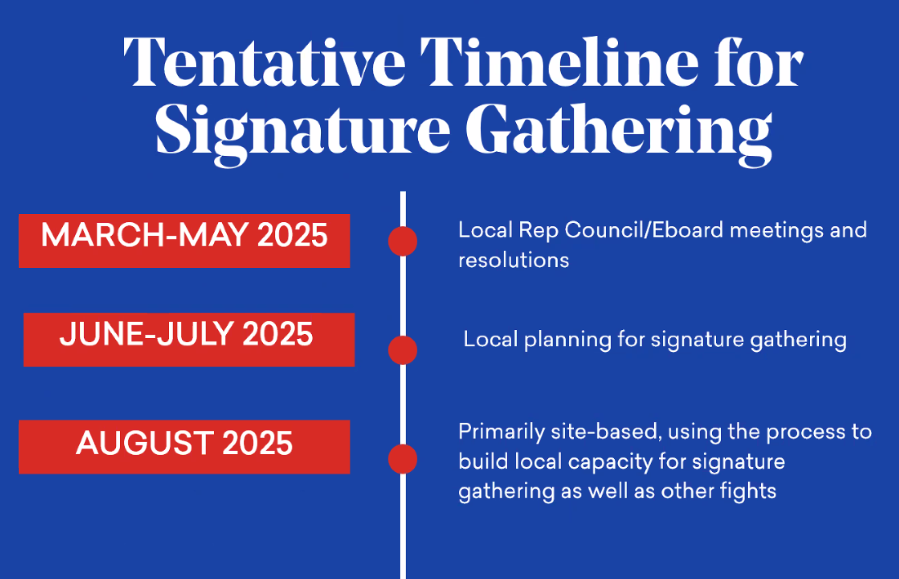
      6. 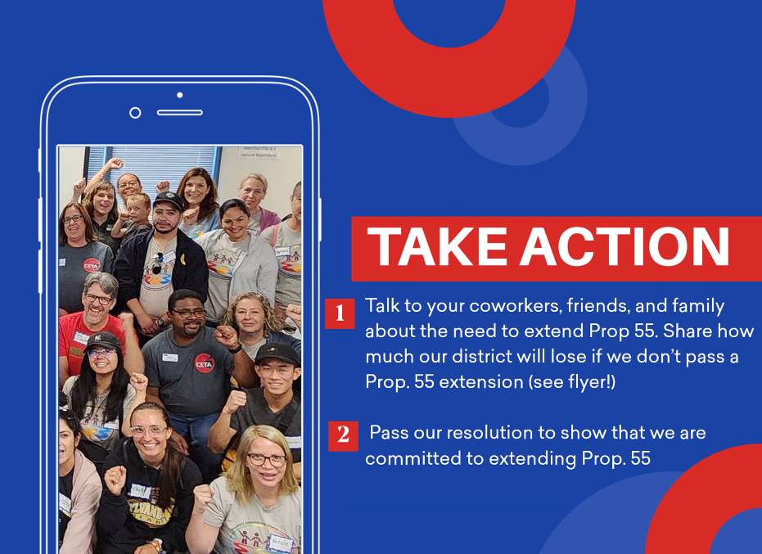
      7. List of all the CCCs and the amount they get from the taxes: <https://www.cccco.edu/-/media/CCCCO-Website/docs/apportionment/23-24-q4-epa-no-payment-exhibit-a-june2024.pdf?la=en&hash=D76C32910D5FC94595C4E425C5D1EE0E341432C7>
         1. All districts have to report their apportionments. They show the amount they were given at certain timeframes along with a recalculation halfway through.
      8. Most of the funds are allowed for many expenditures - outside of administrators wages.
      9. Sample of letter to sign: [prop-55-extension-resolution-sample.docx](https://docs.google.com/document/d/1i8PwEAyAwEyC6KWB0fQELLZpnaXO7_9C/edit?usp=sharing&ouid=111103824869811273500&rtpof=true&sd=true)
      10. Q: How has the feedback from the other unions been receiving this information?
          1. A: Most everyone has been understanding and appreciated learning this and have been supportive of this.
      11. Robert will write out a resolution example and discuss this at the next rep council meeting (May 2025).
      12. Q: Do you think there is a benefit of visiting the legislative representative offices consistently to bring this up and make a point of this legislation? What is the best way to bring this up to the legislative representative?
          1. A: That is definitely something that can help. You can bring up how important it is to fund teachers and services to students if we want to have a strong education system.
      13. CCA Membership Organizing Committee is still giving out grants. CTA is also giving out grants to any union that has a full-time release president. There are also regional grants to support the regional areas. In the spring conference, there is a session about overcoming membership issues.
5. Announcements/ Misc.
   1. Next meeting we will be voting on a Membership Chair (Interested faculty are to send their nomination to [facultyassociation@socccd.edu](mailto:facultyassociation@socccd.edu) by **Friday, April 25, 2025**)and on the PT faculty dues increase.
   2. If you have any agenda items added to the agenda, please send us the information and we can add it to the agenda.
6. Next Rep Council Meeting: Monday, May 5, 2025

Adjourned: 4:56pm

**Meeting Attendance**

| President | Robert Melendez | X | President Elect | Deanna Scherger | X |
| --- | --- | --- | --- | --- | --- |
| Past-President | Lewis Long | x | Chief Negotiator | Claire Cesareo | X |
| Treasurer | Frank Gonzalez | X | Membership Chair | Jenny Langrell | X |
| Secretary | Marianne Wolfe | X | Part-Time Faculty Chair | Danelle Huggett | X |
| Grievance Chair (IVC) | Rebecca Kaminsky | X | Grievance Chair (IVC) | BIll Etter |  |
| Grievance Chair (SC) | BIll McGuire | x | Grievance Chair (SC) | Mark Blethen |  |

| Arts (2) | Gokce Kasikci | X |  |  |  |
| --- | --- | --- | --- | --- | --- |
| Business Science (2) | Rick Boone | x |  |  |  |
| Guidance & Counseling (3) | Javier Valdez | X | Guidance & Counseling (Alt) | Parisa Soltani |  |
| Humanities (3) | Lisa Alvarez | X | Humanities (Alt) | Daniel Vernazza |  |
| IDEA (1) | Massimo Mitolo | X |  |  |  |
| Kinesiology, Health, & Athletics (1) | Jovan Stojanovski | X |  |  |  |
| Languages & Learning Resources (3) | Keith Gamache | X |  |  |  |
| Life Science & Technology (1) | Pierre Nguyen | x | Life Science & Technology (Alt) | Kathy Schmeidler |  |
| Math, Computer Science, & Engineering (2) | Carlo Chan | X |  |  |  |
| Physical Sciences & Technology (2) | Amy Stinson | x |  |  |  |
| Social and Behavioral Sciences (1) | Adam Ghuloum | X |  |  |  |

| Arts, Media, Performance, & Design (5) | BIll McGuire | x |  |  |  |
| --- | --- | --- | --- | --- | --- |
| Business & Industry (2) | Emily Quinlan | X | Business & Industry (Alt) | Kathleen Lunetto |  |
| Counseling & Special Programs (4) | Paris Peck |  | Counseling & Special Programs (Alt) | Mike Long |  |
| Extended Learning (1) | Jill Ibbotson | X |  |  |  |
| Health & Wellness (3) | Loretta Niccola |  | Health & Wellness (Alt) | Samantha Barrett |  |
| Humanities & Social Sciences (6) | Allison Camelot | X | Humanities & Social Sciences (Alt) | Caroline Gee | x |
| Kinesiology (2) | Matt Sherman |  | Kinesiology (Alt) | Jennifer Rohles |  |
| Instructional Support and Teaching Innovations (1) | Jenny Langrell | X | Instructional Support and Teaching Innovations (Alt) | Lydia Tamara |  |
| STEM (6) | Kia Shafe | x | STEM (Alt) | Sam Abbas | x |

| Part Time Representative (1) | Nancy Allah | x | Part Time Representative (1) | Noushin Seddighzadeh |  |
| --- | --- | --- | --- | --- | --- |
| Part Time Representative (1) | Jean Proppe | X | Part Time Representative (1) | John Terranova |  |

Guest: Jane M., Chris C, Robin Devitt (CCA/CTA)