
Minutes
Representative Council Meeting
November 3, 2025

- Call to Order
- Meeting Items
  - Seating representatives:
    - Part-Time Representative Member-at-Large: April Kim, IVC
    - Part-Time Alternate: Katie Tewes, SC, and Tiffani Gamboa, IVC
  - Introduction of Guests
  - Adoption of Agenda
  - Approval of Minutes: October 2025
    - Motion to approved: Allison, seconded: Lewis
    - No discussions, minutes are approved
- Officer and Committee Reports
  - Secretary’s Report—Marianne Wolfe
    - Communications Advisory Committee: if you would like to contribute to the newsletter, let Marianne know.
  - Organizing Committee Report— Deanna Scherger
    - Recap of workshops
    - Upcoming Workshop
      - Your Voice Matters: Get Involved with the Faculty Association!
        - Monday, November 17, 2025 at 3pm-4pm, Zoom: https://ivc-edu.zoom.us/j/84193382653
        - Election in Spring 2026 for the 2026-2028 academic years.
        - Breakdown of the roles and description: http://socccdfa.net/wp-content/uploads/2024/02/SOCCCDFA-ByLaws-and-Rules-Approved-By-Rep-Council-5-1-23-1.pdf
  - Part-time Committee Report— Danelle Huggett
    - Recap of workshops
      - How to Apply for a FT Faculty position
        - Sent out all the materials from the meeting. Please reach out to Danelle if you have questions or would like a copy of the presentation
    - Upcoming workshops
      - How to Apply for Unemployment (first Friday of December)
  - Treasurer’s Report—Frank Gonzalez
    - Dues Deduction Update
      - Over the last 2 pay cycles, there were issues with deductions for the FA membership. Payroll is supposed to have fixed this issue now with the October paycheck. There were issues with charging the local and the CTA membership issues together in the CTA area and ALSO the local SOCCCD dues in a separate one.
      - 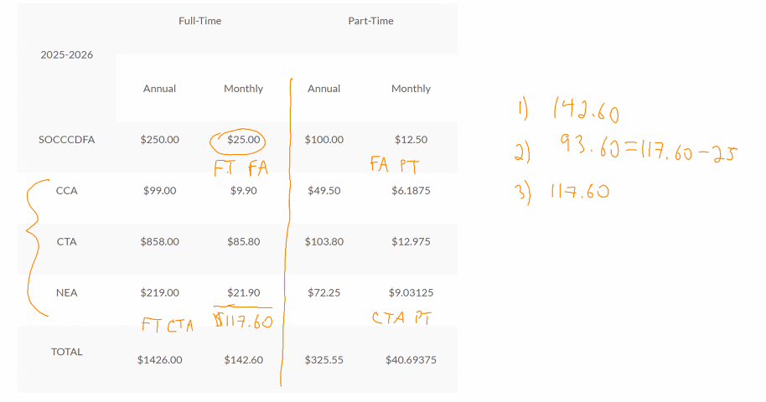
      - For part-time faculty, they are just getting their 2nd paycheck, so the costs may not be accurate in what is being deducted. We are working on this currently to make sure it is updated. Many are only contributing to the local dues, the $100 for the year, and their CTA is coming from another district. So some faculty may not have funds taken out from SOCCCD.
    - Membership Dues Breakdown
    - Part-Time Members-at-Large stipend increase?
      - 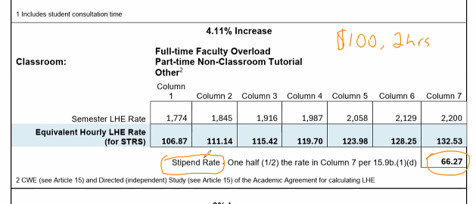
      - Currently we are under the stipend rate based on the current contract. We would like to tie the stipend rate for the part-time faculty representatives to the contract rather than a random number from the past.
      - C: IVC Academic Senate is trying to pass a resolution to have PT faculty compensated for participation in any committees. SC Academic Senate is trying to pass a resolution to compensate PT faculty for participation in AS, which IVC already does and the amount is tied to the contract stipend amount.
      - C: How long has IVC been compensating their PT faculty representative in AS?
        - A: The previous PT Senate rep was not paid, and that was 2 years ago.
      - Q: Why do we have a reserve if it is not reserved to be used for what we need?
        - A: Our college still is a basic aid district but we operate and still follow the state student metrics funding formula. The reserve balances go to the buildings and other items.
        - Q: If the reserves hit a certain amount, is there any policy that requires them to give it back or limit the amount? Or can it just grow forever?
        - A: It could just keep growing forever. If the local community knows about it, then they could go to the Board of Trustees and ask for them to spend it on the campuses, programs, etc. The BOT sets the amount for the taxes and could adjust that if needed. They are spending the money on capital improvements though.
      - Q: Compensation for the FA reps, where would the money come from? Right now we are already cautious of the budget we have in our FA funds and had to raise membership dues last year because of the budget.
        - A: We are not sure of the exact mechanics and would probably need to add this to the negotiations to determine which committees would be selected to pay for the PT participation (probably some of the larger heavy committees).
        - A: The college already is paid by the district to do our work. We would need 2 separate things for the negotiations: a change in the rights of the FA (to allow stipends for PT reps) and also change article 14 to get Academic Senate faculty to get paid for their work.
      - Q: Is the bargaining committee trying to address this issue to ask the district to release money when it is needed?
        - The FA is not in negotiations yet but we do include that is part of the negotiations. Both AS’ are putting together resolutions to ask for this specific issue, so we have a good approach to negotiating this.
      - Q: How are short and long term obligations decided for the district?
        - A: If we are looking at the higher level, that is at the DRAC model and meetings where the budgets are set and approved through that committee and distributed through there. Capital outlay, technology, etc adjustments are made yearly and then there are also special adjustments that happen too. At the college level there are also committees that determine where/how those budget allocations are spent.
        - Q: Where is the list coming from and who decides that?
        - A: It seems to come from Ann Marie Gabel’s office and the discussions are prioritized in the DRAC meetings but the district seems to determine the priorities. It is also driven by the strategic planning committees - like the 5 year master plans for both the district and the individual colleges. From the master plan they determine the priorities and those determine the funding.
  - Negotiations Report—Lewis Long
    - Negotiation Team
      - We need to have selected the team by January - Right now Robert and Deanna are putting names down and seeing who is interested to help develop that team.
      - Trying to make sure we have representation of all areas and have strong voices that are able to reflect and convey the needs of the faculty.
    - Negotiation Timeline
      - Fall 2025 - Development of Team
      - Spring 2026 - Open Forum/Townhall Meeting, survey to all faculty, & creation of sunshine proposal
      - June 1, 2026 - Formal negotiations can begin
    - Working on 4 issues currently:
      - Initial placement with newly hired faculty who are tenured somewhere else - completed. It needs to go out for ratification.
      - Pay for nursing faculty teaching clinical classes outside of the academic calendar - completed, needs to go out for ratification
      - Practicum loading because of Banner issues (cannot load the same teaching activity differently based on faculty status)
      - Lifetime medical for retiree benefits - Blue Cross changed requirement for faculty members who are on medicare - they have to pay for part D. Our contract lists that they only have to pay for part A and B. We are trying to offset the cost for faculty because the supplier is requiring - which is out of our control.
  - Membership Report—Caroline Gee
    - Membership Advisory Committee
    - 23.49% of part-time faculty are members.
  - Grievance Committee
    - Banner doesn’t allow certain loading because of the limitation of not being able to assign different LHE for different roles (PT/FT). So some allowances have been made to let the faculty be loaded higher than the max but this is temporary while they fix it.
    - Q: Banner - is there a time limit that we can “test” Banner before we can go back to our old system? A: There’s a combination of the system not doing something and/or the district just doesn’t know how to do that thing. When do we pull the plug? We don’t have an answer to that. If we feel strongly that there needs to be a change, the faculty voices in the different areas/committees can start to voice things. It probably will not be in less than a year. They will probably try and fail for a couple years before considering throwing in the towel.
      - Q: When can we start thinking of students first and see how the current operating system is harming, not helping.
      - C: I was advised by a highly placed District IT professional that we 100% have the tech capacity to "take a pause" from Banner. However, the admin person with the district who is leading banner implementation is saying that a pause and recalibration of Banner is technically impossible. This difference in information is very concerning. Can we take a pause or not?
      - C: I think on a state level, all districts are encouraged to switch to banner
      - C: These are issues that you - we all should bring up in our senates. The more of us learning & talking about these issues, the more venues we use, the better
      - C: This could be saving us money but it is costing us time.
      - C: Multiple districts gave faculty compensation for changing modalities in 2020. The amount of work everyone has done with Banner, we should insist that we get compensation. Some of that cost savings should be passed down to faculty and staff
      - C: I would like to see the benefits that we can see from the change of Banner. I understand there are changes and struggles with the changeover, but what is the benefit for the students? At the end of the day, what can we show from the switch (outside of saving money) that has positively impacted the students?
      - C: When we transferred from Blackboard to Canvas, there was also a compensation. Some people were paid $5000 for that.
      - A: We negotiated that. We went to the district and told them they were forcing us to do this and it took up a lot of time and effort. We listed what we needed and worked with the district to make it happen. And, we have started discussions on what that compensation could look like for this switch to Banner. The amount of work the faculty member has to do outside of the classroom has increased. We are trying about negotiating the shift and increase in workload to get some compensation for this.
      - Q: How can we request/ensure that the BOT is in receipt of the complete and unredacted results of the recent anonymous Banner implementation survey that was sent out in last week or so? I feel certain that it would be of interest to all BOT members.
      - A: We can add this to the negotiations survey.
      - C: Speaking for the counselors, it has fundamentally changed how we work. There’s been a decrease in students we can serve as well as more backend work.
        - It's not just counselors, it's admissions and records, it's administrative secretaries, it's faculty, everyone has had a larger workload
      - C: However, the recent pay increases have been for COLA, and haven't kept up with actual COLA.
        - C: Although yes, our rate of pay has been increased with each contract. So has our cost of living. Banner's extra level of work simply to help students get added to a course, for instance, is exponentially a higher level of work for all involved.
      - C: I had to spend 4 hours helping a single student add my class at the beginning of the semester.
      - C: There are so many barriers now with the new Banner system. The infrastructure that is surrounding you and your students is being impacted - whether you see it or feel it personally.
      - C: Yes, senior admins need an increase in pay because of Banner. That needs to be negotiated through their union.
      - Q: What are the impacts of the students?
      - A: The core issues are the education plans and ability for the systems - loading comprehensive plans and such. Transcript loading is more tedious. There’s also an accuracy issue. People have to do hand calculations and education plans.
      - C: One of the priorities for the VPSS’ was to allow counselors to see more students. One thing that makes negotiations stronger is to show the different ways things are impacted. In the meantime, use your voice in your spaces to get the details that we can use as evidence in the negotiations.
      - Feel free to keep updating us and let us know the issues that come up.
  - PAC Report – Robert Melendez
    - Next Election November 2026
      - Areas 2 - Irvine, Orange, Tustin, and Santa Ana
      - Area 4 - Dana Point, Rancho Santa Margarita, San Clemente, San Juan Capistrano, Coto de Caza, Ladera Ranch, Rancho Mission Viejo, and Trabuco Canyon
      - Area 5 - Irvine, Laguna Hills, Laguna Woods, Lake Forest, and Mission Viejo
    - Missing PAC representatives
      - Will be having another PAC meeting in January/February
    - PAC Contributions: http://www.socccdfa.net/ESW/Files/PAC_Payroll_deduction_form%5B1%5Dfillablepdf-1.pdf
  - CCA/CTA Regional Report – Sam Abbas
  - Contract Corner - Deanna Scherger
    - Workload exchanges
      - Contract Corner: Work Exchange
        - C: A lot of times if they are exchanging, the main faculty helps set up the lesson plan for the exchange professor to use.
        - C: You cannot use it in the summer and it cannot rollover from spring to fall as it needs to be used in the same academic year. The current verbiage is vague and the summer wasn’t supposed to be used for this but we should clarify it in the summer.
        - C: We had a situation this summer where an area stated that workload exchange was not an option in summer. We worked with district to clarify that faculty can utilize workload exchange in the summer. We agreed we would update the language in the contract during the next negotiation cycle.
        - A: Many faculty take sick days because the dean pressures them to do the work load exchange but there seems to be a lot of work entailed in it. Many are hesitant to take the workload exchange because they don’t know what it entails.
        - C: Deans should not be involved in the work load exchange. The work load should be there for the faculty to use and should not be suggested to be used instead by the deans.
        - C: I can talk to the VPI’s at each college to make sure they work with their deans to be aware of the way they present options and not pressure faculty.
        - C: Also, if my colleague is up for it, I enjoy introducing my GREAT colleagues to my students so they can become acquainted with other faculty and I enjoy meeting their students when I fill in for them.
        - C: Some people do not want to use sick leave or their personal days. Sick leave and personal days come from a different fund. If the deans do not want to get a sub, they should be stopped. Workload exchange is for the faculty to use as they want, not for deans to use instead of hiring a sub.
        - C: In the past we got emails requesting people to donate sick leave. If we did workload exchange, we could prevent people from using sick leave or needing to use all of theirs.
  - Faculty Workload and School/Department Share-out (10 Minutes) - Representatives are able to provide updates on current workload issues, challenges, and successes within their schools/departments. This is an opportunity to identify patterns, highlight concerns related to working conditions, and share ideas or needs that may require union support or further advocacy.
    - Sign-up Link - https://docs.google.com/document/d/1oYDCsAnJPKn8K_4DPavigi1h42T3ZhLswWa5eYdBKwk/edit?usp=sharing
  - Physical Science & Technology @ IVC (Amy S) - B200 maintenance issues
    - The building has had inconsistent heating and cooling. Offices were 85 degrees in summer and classrooms could get hotter. Robert reached out to the facilities to help. The HVAC maintenance company said it is IVC’s issue and they have control over it. There’s also issues with ADA compliance, holes in the walls. There have been some improvements but the building is still having a lot of issues.
- Information
  - CCA Fall Conference Delegate Report
    - The conference was very productive and successful. Talked about PT issues and many of the workshops had to deal with addressing those. There was also a focus on membership and increasing involvement. They talked about the voting for the redistricting and emphasized the vote and implications if it passes or not. There were many representatives from Saddleback who attended.
  - Getting Your Voice Heard
    - Ways to give highlights to the Board and district as a whole
    - Tea with the Board
      - Saddleback College (Location: CC212)
Wednesday, October 29, 2025
3:00 - 4:30pm
      - Irvine Valley College (Location: A311)
Tuesday, November 4, 2025
3:00 – 4:30pm
  - CCA Conference Grants: https://www.cta.org/conferences/grants
- Announcements/ Misc.
  - If you have any agenda items added to the agenda, please send us the information and we can add it to the agenda.
- Next Rep Council Meeting: Monday, December 1, 2025 at 3pm on Zoom

Adjourned: 5:03PM
Meeting Attendance

President | Robert Melendez | X | President Elect | Deanna Scherger | X
Past-President | Lewis Long | X | Chief Negotiator / Grievance Chair (SC) | Claire Cesareo
Treasurer | Frank Gonzalez | X | Membership Chair | Caroline Gee | X
Secretary | Marianne Wolfe | X | Part-Time Faculty Chair | Danelle Huggett | X
Grievance Chair (IVC) | Rebecca Kaminsky | X | Grievance Chair (IVC) | BIll Etter
Grievance Chair (SC) | BIll McGuire | X | Grievance Chair (SC) | Allison Camelot | X

Arts (2) | Gokce Kasikci | X
Business Science (2) | Rick Boone
Guidance & Counseling (3) | Javier Valdez | X | Guidance & Counseling (Alt) | Parisa Soltani
Humanities (3) | Lisa Alvarez | X | Humanities (Alt) | Daniel Vernazza
IDEA (1) | Massimo Mitolo | X
Kinesiology, Health, & Athletics (1)
Languages & Learning Resources (3) | Keith Gamache | X
Life Science & Technology (1) | Pierre Nguyen | X | Life Science & Technology (Alt) | Kathy Schmeidler | X
Math, Computer Science, & Engineering (2) | Mohamad Youssef | X
Physical Sciences & Technology (2) | Amy Stinson | x
Social and Behavioral Sciences (1) | Adam Ghuloum | X

Arts, Media, Performance, & Design (5) | BIll McGuire | X
Business & Industry (2) | Emily Quinlan | x | Business & Industry (Alt) | Kathleen Lunetto | x
Counseling & Special Programs (4) | Michael Hoggatt | X | Counseling & Special Programs (Alt)
Extended Learning (1) | Jill Ibbotson | X
Health & Wellness (3) | James Major | X | Health & Wellness (Alt) | Samantha Barrett
Humanities & Social Sciences (6) | Allison Camelot | X | Humanities & Social Sciences (Alt)
Kinesiology (2) | Matt Sherman | X | Kinesiology (Alt) | Jennifer Rohles | X
Instructional Support and Teaching Innovations (1) | Lydia Tamara | X | Instructional Support and Teaching Innovations (Alt) | Alicia Zach
STEM (6) | Kia Shafe | X | STEM (Alt) | Sam Abbas

Part Time Representative (1) | Nancy Allah | X | Part Time Representative (1) | April Kim | X
Part Time Representative (1) | Jean Proppe | X | Part Time Representative (1) | John Terranova | X

