
Minutes
Representative Council Meeting
December 1, 2025

- Call to Order: 3:02pm
- Meeting Items
  - Introduction of Guests: Chris C
  - Adoption of Agenda
    - Motion to approve: Sam A, second: Massimo
    - No discussion
    - Motion approved
  - Approval of Minutes: November 2025
    - Motion to approve: Kathy S, second: Allison C
    - No discussion
    - Motion approved
- Officer and Committee Reports
  - Secretary’s Report—Marianne Wolfe
    - Communications Advisory Committee - Should have newsletter out later this week/early next week
  - Organizing Committee Report— Deanna Scherger
    - Recap of workshop
      - Your Voice Matters: Get Involved with the Faculty Association!
        - Access to the Zoom: Zoom Recording
        - Access to the Presentation: Get Involved with the Faculty Association Workshop Presentation
        - Some feedback was that people want to get involved but don’t know how. We plan to have more workshops in spring to share opportunities for involvement and ways to support the FA through committee work and election prep.
  - Part-time Committee Report— Danelle Huggett
    - Recap of workshops
    - Upcoming workshops
      - Unemployment workshop (on Zoom) - December 11th is the tentative date but waiting on confirmation from HR/Payroll.
      - A part-time health insurance reimbursement workshop in January 2026 during Flex Week.
  - Treasurer’s Report—Frank Gonzalez
    - Voting Item: Part-Time Members-at-Large Stipend Increase (To start in Spring 2026)
      - $520.64 increase for Spring 2026. The rate is $71.99 for 2026-2027, $4,607 for the line item. Increase for the 2027 year: $1407.36.
      - Q. With the increase in the PT stipend rate, would this be accounted for in the increase in dues?
      - A. Yes, the increase does get covered by the increase in dues but we had already wanted to increase dues based on the large reserve of funds we have been whittling down.
      - Motion to approve raising the compensation rate for part-time members at large to be the contract stipend rate vote: Kathy S, seconded: Wonderful Nancy
      - Discussion
        - Q: Senate for IVC/SC both passed resolutions to approve PT faculty to be part of committees in the next contract cycle. If this is approved, would the FA have to pay for the stipend rates or would that come from AS’ funding.
        - A: Potentially it could. We would need to see how it is worded in the contract. The district may make the wording very specific like, only specific committees and specifically assigned to this, etc.
        - C: FT faculty members are compensated for equivalent to 1 hour a week for committee/service to the college. My guess would be that it may be similar to how the PTs get paid for their committee work. (e.g. we serve on multiple committees but only get the 1 committee compensation). We have negotiated in the past of making requirements for PTs as a move towards parity (committee service and PD). In the past, some of the PT pushed back because of the requirement that would conflict with the other schools they may be working at). For the district to pay for it, they wanted to make it a requirement. But there was concern that the requirement was not what all the PT membership wanted.
        - C: Today we are looking at voting on just our PT membership compensation. The extra question about the AS approved stipend is more of a future discussion/something to think about as the contract opens up. With the PT rep on the negotiations team, they could work with the PT faculty to get a better idea of what is desired.
        - C: We have attempted to get college service in PT’s PD payment but we have not been successful. The AS resolution can help with the request. The AS resolution was for PT to participate in some of the specific college regulatory committees. It is something we have worked towards for the past 8 years if not more.
      - Vote: Unanimously passed
      - Motion passes
  - Negotiations Report—Lewis Long
    - MOU progress - 4 are in the process of approval
      - Salary schedule placement for new hires who were previously tenured at another college so their tenure will be accounted for in placement
      - Clinical pay for nursing faculty who are working outside of the academic calendar. This was intended to replace extra duty days but nursing faculty use those days to do other things.
      - Practicum loading - in the final stages of that as this will be a change to the MOU.
      - Part D MediCare requirement that our insurance is placing on retirees. The district doesn't have an option. The health insurance provider is requiring this. The contract says they will only pay for certain things only. Now the retirees have to pay for vision, the cost is comparable. And the rest will be covered by the district. Once we clean up the language, we will send this out to the rest of the membership to vote on.
        - Q: Spouses not covered anymore once they retire - can you elaborate on this?
        - A: Previously they were not covered but we implemented a change where spouses could buy into the coverage as well. Once you are retired and reach MediCare eligibility, your spouse has to pay for A, B, and D as well as purchase additional coverage and vision and dental. Cost wise might not be comparable but the quality should be very good for the cost.
      - Vote on the MOU items will take place in Spring 2026.
    - Negotiation Team
    - Negotiation Timeline
      - Fall 2025 - Development of Team
      - Spring 2026 - Open Forum/Townhall Meeting, survey to all faculty, & creation of sunshine proposal
        - This will take place during the Spring 2026 Flex Week meeting (info below).
      - June 1, 2026 - Formal negotiations can begin
  - Membership Report—Caroline Gee
    - Membership Advisory Committee
    - Full Time Faculty Membership List
    - Part Time Faculty Membership List
    - Numbers for spring may change as we have new hires and such.
  - Grievance Committee
    - Faculty do not have vacation days. We have sick time, personal necessity time, etc. You have to make sure you request the time off correctly. You cannot just say you’re taking vacation and not show up. You have to report it. People have gotten into trouble previously who may have reported their sick time, etc.
    - C: If you do not use your personal necessity, does it roll over?
    - A: You have a certain amount of sick time (FT has 10 days and 6 can be used towards PN). The PN time is charged from your sick time.
    - C: You should be aware that your sick time from overload comes from a different pot of sick leave. So you have to log it accordingly.
    - Q: When does the sick time reset? Calendar or academic year?
    - A: Academic year
  - PAC Report – Robert Melendez
    - Next Election November 2026: https://www.socccd.edu/board-trustees/district-maps
      - Areas 2 - Irvine, Orange, Tustin, and Santa Ana
      - Area 4 - Dana Point, Rancho Santa Margarita, San Clemente, San Juan Capistrano, Coto de Caza, Ladera Ranch, Rancho Mission Viejo, and Trabuco Canyon
      - Area 5 - Irvine, Laguna Hills, Laguna Woods, Lake Forest, and Mission Viejo
    - Robert has been meeting with different board members and discussing working conditions, etc.
    - Will be setting up 3 PAC meetings in Spring 2026 to prepare rolling into summer. We anticipate a couple more meetings in summer as well. We will need to do PAC work heavily during summer but some things have started already.
    - PAC Contributions: http://www.socccdfa.net/ESW/Files/PAC_Payroll_deduction_form%5B1%5Dfillablepdf-1.pdf
      - Q: Can you do a one-time contribution?
      - A: You can do that by making a payment directly to the SOCCCD FA PAC.
  - CCA/CTA Regional Report – Sam Abbas
    - Friends! Here is my CCA State Report: CCA held a board meeting in Sacramento on Nov. 7th and 8th and on the table were discussions that included among several other things:
      - Reflection Recap/evaluation of the outcomes of October conference in San Francisco
      - Discussion for a need to have a board meeting in December: approved and will be in Sac on December 12-13.
      - Planning for the 2026 CCA Winter Conference which will take place on February 27th till March1st at the Hilton Orange County in Costa Mesa. During the meeting District E director (rep. for College of the Canyons, Kern CC FA, Taft College FA) resigned.
  - Contract Corner - Robert
    - 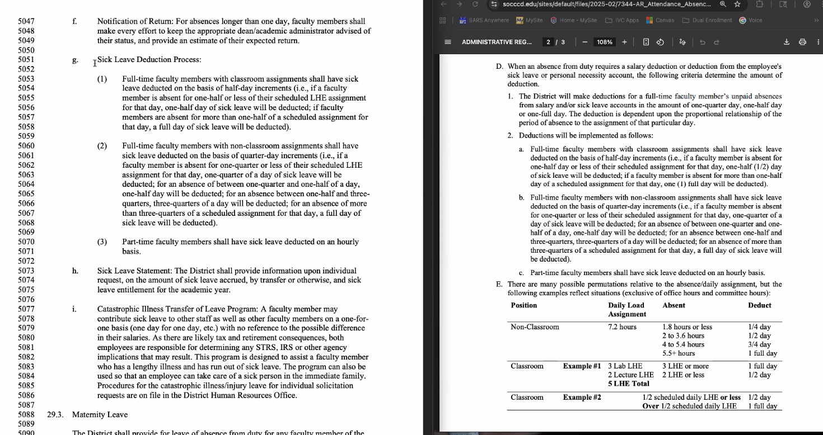
      - https://www.socccd.edu/sites/default/files/2025-02/7344-AR_Attendance_Absence%20Reporting%20Procedures-Faculty%202.13.25.pdf
    - Days and Hours in Banner and the CBA for Sick Time
    - For Load
      - 1 Day = 7.2 hours
      - ½ Day = 3.6 hours
    - For Overload and PT Faculty
      - Deducted hour for hour
    - Discussion:
      - Q: I only teach 2 hours for the day I use sick time for. Some people say it’s a full day I have to take but some say it is just a half day.
      - A: Our work load is 36 hours a week, which is broken down to 7.2 hours a day for the week. By contract and calendar, if you take off more than your assigned hours for the day, you have to take the full day. If all you have is that 1 class on that day, then that is a full day (even though the hours of the class is less than 7.2 hours). But, if you do other work that day (committee time, office hours, etc) that you work with your dean, you may have justification to only do the half day time off since you are doing other faculty roles/responsibilities even outside of your class meeting.
      - Q: How are you counting committee meetings that we miss? Would we then have to use sick time for that meeting? It feels like dangerous territory. We need to tread carefully on what we want moving forward.
      - Q: If we have to take full days, should we advise people to not do their office hours or other faculty duties since we will be charged the full amount even if we are only missing part of the day?
      - A: That is probably more up to the faculty. Most faculty always feel a bit behind, so they probably will keep working but it is an option to not work the whole day.
      - Q: For non-classroom faculty, if we work more than 7.2 hours, do we need to claim more hours for sick time? Or would it be fine just doing 7.2?
      - A: If it is all your contract hours, then you would just need to do the 7.2 even if you do more hours. If any part of that day is overload, then you would need to also submit the sick time per hour for the overload hours.
      - C: Think about the pay, so even if you only teach for 2 hours on that day you are getting paid for the whole day.
      - Q: Does that take into account prep and grading which is also part of our hours for the weeks?
      - A: But a consequence of this may be that faculty arrange their teaching schedule in big chunks rather than spreading out teaching across the week. Arguably, if we claim prep time was work time for the purposes of calculating sick leave, the District could attempt to require us to document our prep time. I would also hate to put us in that position. Although, upon further consideration, it might be interesting to account for prep time to demonstrate that 1hour prep per hour in class is undercounting.
- Information
  - CCA Winter 2026 Conference: February 27 - March 1, Hilton Orange County
  - CCA Spring 2026 Conference: April 24 - 26, Irvine Marriott
  - CCA Conference Grants: https://www.cta.org/conferences/grants
- Announcements/ Misc.
  - If you have any agenda items added to the agenda, please send us the information and we can add it to the agenda.
  - AI discussion in Academic Senate - There’s a tool, GPT Zero, that can be used to check AI use. If we host a session about GPT Zero, they are offering an opportunity to get a free semester of GPT Zero to try out. Emily Q will be hosting a Zoom workshop on Jan 8th at 2pm during Flex Week and will give the attendees free semester use. Here is the link for more information about the tool: https://scale.stanford.edu/ai/repository/assessing-gptzeros-accuracy-identifying-ai-vs-human-written-essays
  - Q: Is there any recourse for students using AI?
  - A: Not really at this point outside of the normal academic dishonesty process. But, the issue is rising amongst the students.
  - Check this out - from Columbia School of Journalism: What Happens After A.I. Destroys College Writing?
- Next Rep Council Meeting:
  - Spring 2026 Flex Week Meeting and Negotiations Town Hall
Tuesday, January 6, 2026 from 11:30am-1pm
Zoom - https://ivc-edu.zoom.us/j/87558368875

Adjourned: 4:36pm
Meeting Attendance

President | Robert Melendez | X | President Elect | Deanna Scherger | X
Past-President | Lewis Long | X | Chief Negotiator / Grievance Chair (SC) | Claire Cesareo | X
Treasurer | Frank Gonzalez | X | Membership Chair | Caroline Gee | X
Secretary | Marianne Wolfe | X | Part-Time Faculty Chair | Danelle Huggett | X
Grievance Chair (IVC) | Rebecca Kaminsky | X | Grievance Chair (IVC) | Bill Etter
Grievance Chair (SC) | BIll McGuire | X | Grievance Chair (SC) | Allison Camelot | X

Arts (2) | Gokce Kasikci | X
Business Science (2) | Rick Boone | X
Guidance & Counseling (3) | Javier Valdez | X | Guidance & Counseling (Alt) | Parisa Soltani
Humanities (3) | Lisa Alvarez | X | Humanities (Alt) | Daniel Vernazza
IDEA (1) | Massimo Mitolo | X
Kinesiology, Health, & Athletics (1)
Languages & Learning Resources (3) | Keith Gamache |  | Languages & Learning Resources (alt) | Winnie Dinh | X
Life Science & Technology (1) | Pierre Nguyen | X | Life Science & Technology (Alt) | Kathy Schmeidler | X
Math, Computer Science, & Engineering (2) | Mohamad Youssef | X
Physical Sciences & Technology (2) | Amy Stinson | X
Social and Behavioral Sciences (1) | Adam Ghuloum | X

Arts, Media, Performance, & Design (5) | BIll McGuire | X
Business & Industry (2) | Emily Quinlan | X | Business & Industry (Alt) | Kathleen Lunetto
Counseling & Special Programs (4) | Michael Hoggatt | X | Counseling & Special Programs (Alt)
Extended Learning (1) | Jill Ibbotson | X
Health & Wellness (3) | James Major | X | Health & Wellness (Alt) | Samantha Barrett
Humanities & Social Sciences (6) | Allison Camelot | X | Humanities & Social Sciences (Alt)
Kinesiology (2) | Matt Sherman | X | Kinesiology (Alt) | Jennifer Rohles | X
Instructional Support and Teaching Innovations (1) | Lydia Tamara | X | Instructional Support and Teaching Innovations (Alt) | Alicia Zach
STEM (6) | Kia Shafe | X | STEM (Alt) | Sam Abbas | X

Part Time Representative (1) | Nancy Allah | X | Part Time Representative (1) | April Kim | X
Part Time Representative (1) | Jean Proppe | X | Part Time Representative (1) | John Terranova
Part Time Rep Alternate | Tiffani Gamboa | X | Part Time Rep Alternate | Kate Tewes

